

Executive Summary & Annual Report

2021-2022

Submitted by Cameron Ward MaPSAC Chair 2021-2022
May 2022

TABLE OF CONTENTS

- EXECUTIVE SUMMARY – SUBMITTED BY CAMERON WARD, MAPSAC CHAIR 2021-2022 3
  - Purpose 3
  - Official Reporting Period 3
  - Major Topics 3
  - Goals for the 2020-2021 Year 4
  - Other Notable Accomplishments 4
  - Looking Forward 4
- ANNUAL REPORT 5
  - Full Committee Report - Submitted by Cameron Ward, MaPSAC Chair 2021-2022 5
  - Ongoing Priorities for MaPSAC 8
- SUBCOMMITTEE REPORTS 9
- Compensation and Benefits – Submitted by Wesley Shoop, Subcommittee Chair 9
- Membership and Communications – Submitted by Angie Sigo, Subcommittee Chair 10
- Professional Development – Submitted by Michael Springer, Subcommittee Chair 13
- UNIVERSITY COMMITTEE REPORTS 15
  - College of Engineering Dean’s Staff Advisory Council – Submitted by Suzanne Zurn-Birkhimer, MaPSAC Representative(s) 15
  - Eudoxia Girard Martin Award – Submitted by Denton Sederquist, MaPSAC Representative(s) 16
  - Recreation & Wellness Advisory Board – Submitted by Clinton Pruitt, MaPSAC Representative(s) 16
  - Retirement Plan Committee – Submitted by Dean Lingley, MaPSAC Representative(s) 17
  - Staff Memorial Committee – Submitted by Cameron Ward, MaPSAC Representative(s) 17
  - Survey Oversight Committee– Submitted by Collen Banter, MaPSAC Representative(s) 18
  - University Policy Committee – Submitted by Angie Sigo, MaPSAC Representative 19
  - University Senate – Submitted by Amanda Emmons, MaPSAC Representative(s) 19
  - University Senate (Faculty Committee): Staff Appeal Board for Traffic Regulations – Submitted by Michael Springer, MaPSAC Representative(s) 34
  - University Senate Advisory Committee – Submitted by Cameron Ward, MaPSAC Representative(s) 35
  - University Senate: Committee for Sustainability – Submitted by Anna Subramaniam, MaPSAC Representative(s) 35
  - University Senate: Equity and Diversity Standing Committee – Submitted by Deidre Bush, MaPSAC Representative(s) 37
  - University Senate: Faculty Compensation & Benefits Committee – Submitted by Samanthi Obeyesekera, MaPSAC Representative(s) 38
  - University Senate: Parking & Traffic – Submitted by Stephanie Winder, MaPSAC Representative(s) 39
  - University Senate: Vision Arts and Design Committee –Submitted by Tony Mull, MaPSAC Representative 40
- OTHER COMMITTEE/TASK FORCE REPORTS 41
1 | P a g e
- New Employee Experience Program – Submitted by Amanda Emmons, MaPSAC Representative(s) 41
- Protect Purdue Task Force – Submitted by Cameron Ward, MaPSAC Representative(s) 41
- REGIONAL CAMPUS REPORTS 42
  - Purdue Fort Wayne – Submitted by Regina Gordon, MaPSAC Representative(s) 42
  - Purdue Northwest – Submitted by Deborah Bachmann, MaPSAC Representative(s) 42
- APPENDIX A – MAPSAC STRATEGIC PLAN 43
- APPENDIX B – PURDUE EQUITY TASK FORCE STRATEGIC PLAN 45

2 | P a g e

EXECUTIVE SUMMARY – SUBMITTED BY CAMERON WARD,
MAPSAC CHAIR 2021-2022

Purpose
Since 1988, MaPSAC has been a partner of the administration to improve Purdue University with respect to staff well-being.

According to Policy V.B.2 taken from www.purdue.edu/policies/governance/vb2.html

It is Purdue University's policy to solicit and carefully consider suggestions and advice from Management and Professional staffs (M/P) when forming University policies and procedures and in other matters relating to the terms and conditions of staff employment. To this end, the Management and Professional Staff Advisory Committee (MaPSAC) serves as a representative committee of M/P staff.

Subject matter for discussion and action by MaPSAC may originate by any of the following methods:
- By the University administration via any of its officers or unit heads or by chairpersons of duly appointed University committees;
- By any individual staff member via a member of the committee; or
- By placing a written and signed statement of the matter on file with the committee.

MaPSAC acts as a sounding board to give feedback on administrators’ proposals. MaPSAC considers matters from staff and provides recommendations to the administration. MaPSAC facilitates communication between staff and senior administrators.

Official Reporting Period
The official reporting period is from January 1, 2021 to December 31, 2021. However, additional highlights from January 1, 2022 - May 31, 2022 have been included.

From January 1, 2021 to May 31, 2021:
The MaPSAC Chair was Stacey Baisden and the Vice Chair was Cameron Ward.

From June 1, 2021, to June 1, 2022:
The MaPSAC Chair was Cameron Ward and the Vice Chair was Amanda Emmons.

Major Topics
Protect Purdue Charge (Cont’d) Adjustment to off-site/remote work.
Remote work equity and standards for allowing off-site work

Goals for the 2020-2021 Year
  - Further develop and enhance communication, collaboration and partnerships with university administration and leadership bodies
  - Collaborate with senior leadership in the transition to remote working, de-densification on campus
  - Ensure Management and Professional staff have a chance and outlet to provide feedback regarding major changes happening within Purdue University

Other Notable Accomplishments
The MaPSAC Chair and Vice Chair Continue attending Protect Purdue meetings with Provost Akridge and other leaders across campus weekly throughout 2021. The other leaders within the Protect Purdue meetings were the Chair and Vice Chair of CSSAC, the Chair and Vice Chair of the University Senate, the President and Vice President of the Purdue Student Government Association, and the President of the Graduate Student Government Association. Starting with the Spring 2021 semester, the leaders decided collectively to meet every other week. These meeting are specifically Protect Purdue meetings where thoughts and insight were shared to senior administration. During these meetings, the Chair and Vice Chair worked with senior administration to provide feedback from Management and Professional staff at Purdue University.

Through the Protect Purdue meetings MaPSAC helped University Senate create campus-wide surveys to gauge the remote working transition. Through the surveys MaPSAC helped contribute to town hall meetings and advise senior administration on the challenges that Management and Professional staff were facing.

Looking Forward
Two enterprise environmental factors are highly influential in a large university like Purdue.

- Fostering an inclusive environment that eschews “us versus them” thinking.
- Encouraging clear and frank communication so that opportunities are not lost to fear of speaking up.

Increased transparency and engagement between administrators, staff, and faculty tends to create benefits in both the short and long term. MaPSAC facilitates this communication and strives to help foster a culture and community of communication and cooperation in good faith.

4 | P a g e

ANNUAL REPORT

Full Committee Report - Submitted by Cameron Ward, MaPSAC Chair 2021-2022
Since 1988, MaPSAC has been a partner of the administration to improve Purdue University with respect to staff well-being.

According to Policy V.B.2 taken from www.purdue.edu/policies/governance/vb2.html

It is Purdue University's policy to solicit and carefully consider suggestions and advice from Management and Professional staffs (M/P) when forming University policies and procedures and in other matters relating to the terms and conditions of staff employment. To this end, the Management and Professional Staff Advisory Committee (MaPSAC) serves as a representative committee of M/P staff.

Subject matter for discussion and action by MaPSAC may originate by any of the following methods:
- By the University administration via any of its officers or unit heads or by chairpersons of duly appointed University committees;
- By any individual staff member via a member of the committee; or
- By placing a written and signed statement of the matter on file with the committee.

MaPSAC’s discussions, resolutions, and communications benefit staff and the mission of the University. By combining our brainpower and sharing our experiences across this diverse group from throughout the West Lafayette campus and the entire Purdue system, we see patterns and devise creative solutions that a lone office could never realize.

Not only does MaPSAC constitute a representative group of Management and Professional staff available to give feedback on proposals, but members also reach out to their areas to share information and begin to effect change. We have nearly 5,000 Management and Professional staff at Purdue, MaPSAC comprises of 25-30 voting members: 21 selected from across 11 groups that span all areas of the West Lafayette campus, one from each regional campus site, and up to five
members-at-large.

As an advisory committee, MaPSAC meets monthly to discuss and make recommendations on issues that are important to Management and Professional staff. Much of the committee’s work is completed through our subcommittees of Compensation and Benefits, Membership and Communications, and Professional Development.

During our 2021-2022 year, MaPSAC served on 27 University committees, task forces, and focus groups. Reports from MaPSAC subcommittees and from University committees can be found below this Full Committee Report.

The official reporting period is from January 1, 2021 from December 31, 2021. However, additional highlights from January 1, 2022 - May 31, 2022 have been included. From January 1, 2021 to May 31, 2021 the MaPSAC Chair was Stacey Baisden and the Vice Chair was Cameron Ward. From June 1, 2021, to June 1, 2022 the MaPSAC Chair was Cameron Ward and the Vice Chair was Amanda Emmons.

MaPSAC’s ongoing focus is to provide better service to staff through increased communications, increased visibility, and proactive action on issues that are important to Management and Professional staff and the University.

During the January 1, 2021 – December 31, 2021 timeframe
- Continued and intensified improvements to our monthly email newsletter, The Sentinel where we are in partnership with the HR – Communication team. The HR – Communication team helps MaPSAC send the monthly communication using Delivra. Having HR – Communication team send out our communications helps unify The Sentinel. It also helps MaPSAC ensure Purdue brand is followed. Ongoing improvement involves working with our CSSAC peers to bring the two committees’ newsletters into better alignment in terms of content and scope, as well as improved utilization of resources and technologies available at the University.
- Promoted and sponsored professional development and self-improvement programs and surveyed colleagues for feedback.
- In May, we awarded the 2021 MaPSAC Excellence Award to Vanessa Pacheco, Civic Engagement & Leadership Development.
- In October, we awarded the 2021 Community Spirit Award to Krista Hixson-Titlow, associate director of capital projects, University Residences
- In December, we awarded the 2021 recipient of the Eudoxia Girard Martin Memorial Staff Recognition Award to 2021 Recipient: Cindy Holderbaum, Weldon School of Biomedical Engineering
- From June 2021-May 2022 during our MaPSAC Executive Committee meetings the MaPSAC Chair continued team builder/ice breaker events to develop our MaPSAC Executive Subcommittee team.
- From June 2021-May 2022 during our MaPSAC full committee meetings roll call takes place. During roll call, to get to know each other in a virtual setting, the Chair asks one question for every person to answer (intermittently). Examples: What is your favorite color? What is your favorite dessert? What is your favorite holiday? What are you looking forward to most over winter break? Etc. This has created a virtual camaraderie among the organization as a third of our organization has never met in person.
- Invited several guest speakers to our MaPSAC full committee meetings to present current issues for MaPSAC consideration (see list below)
  - January 13, 2021
    - Brenda Coulson, Director, Talent Acquisition
  - February 10, 2021
    - Lisa Heider, Recreation & Wellness

6 | P a g e

- March 9, 2021 – Joint meeting with CSSAC
  - President Mitch Daniels
- April 14, 2021
  - Jessica Robertson, Director of Procurement
  - Robert Wynkoop, Associate Vice President, Administrative Operations
- May 12, 2021
  - Deborah Nichols – University Senate Chair
  - Bill Bell, Vice President for Human Resources
- June 9, 2021 – held orientation ***transition of MaPSAC Full Committee and the Executive Subcommittee
  - Bill Bell, Vice President for Human Resources
  - Adedayo Adeniyi, Office of VP of Human Resources
  - Carrie Hanson, Office of VP for Human Resources
- July 14, 2021
  - Bill Bell, Vice President for Human Resources
- August 11, 2021
  - Jessica Robertson, Senior Director Procurement
  - Sabra Moulton, Assistant Director of Procurement
  - Janessa Martin, Manager of Procurement Services
  - Brenda Coulson, Director Talent Acquisition
- September 8, 2021
  - Ms. Angela Dodd, Vice President of Purdue Black Alumni Organization
  - Dr. Gina DelSanto, Chief of Staff
- October 12, 2021 – Joint meeting with CSSAC
  - Bill Bell, Vice President for Human Resources
  - Dr. Gina DelSanto, Chief of Staff
  - Mr. Ian Hyatt, Vice President for Information Technology and CIO
- November 10, 2021
  - Chancellor Frank Dooley, Purdue Global
  - Bill Bell, Vice President for Human Resources
- December 8, 2021
  - Bill Bell, Vice President for Human Resources

During the January 1, 2022 – May 31, 2022 timeframe
- At our January meeting we held a MaPSAC Winter Social in a virtual platform where the purpose was to get to know each other better. Kristen Miller helped us randomize names where we sent a card or something small for no more than $5 total value. It could be homemade, cutesy, and/or funny. Then we opened them up during our meeting. Participation was optional and we had participation from about half our membership.
- At our January Executive meeting we also discussed and approved a new 3-year strategic plan, detailing steps for MaPSAC to take to improve engagement in measurable ways and detailing specific milestones to achieve in the next 3 years.

- At our February meeting we engaged again the resources and expertise of Remingtin Mickle – Coordinator for Leadership & Professional Development, who helped us through the Strengths 101 and 201 workshops, helping members identify strengths and learn how to build efficient teams and working groups using this information.
- In May we awarded the 2021 MaPSAC Excellence Award to Vanessa Pacheco, Civic Engagement and Leadership Development Office.
- Invited several guest speakers to our MaPSAC full committee meetings to present current issues for MaPSAC consideration (see list below)
  - January 12, 2022
    - Bill Bell, Vice President for Human Resources
  - February 9, 2022
  - Remingtin Mickle – Coordinator for Leadership & Professional Development
  - March 8, 2022 – Joint meeting with CSSAC
    - Mitchell Daniels, President – presented on the state of the university
    - Dr. Jerome Adams, Executive Director of Health Equity Initiatives
    - Dr. Deb Nichols, Past Chair, University Senate
    - Bill Bell, Vice President for Human Resources

Ongoing Priorities for MaPSAC
Our ongoing priorities for MaPSAC include:
- University Senate proposed model of shared governance changes
- Ensuring a continued partnership with CSSAC and the University Senate.
- 2022-2024 MaPSAC Strategic Plan
- Potential MaPSAC diversity structural expansion (providing MaPSAC Executive Subcommittee, MaPSAC Full Committee and Vice President of HR Bill Bell approves. Approvals still pending when Annual Report was submitted)
- Ensuring the continuation of the MaPSAC/CSSAC annual Staff Memorial service each April/May
- Increasing the frequency and usefulness of communication with colleagues
- Maintaining positive relationship with senior leadership
- Continuing to assist with the Protect Purdue remote working, ensuring equal access to remote resources and providing a forum to discussions about equity more generally.
At the April 13, 2022 meeting, JJ Abrams was elected MaPSAC Vice Chair for 2022-2023. Amanda Emmons becomes MaPSAC Chair on June 1, 2022. During the next year, MaPSAC leadership hopes to focus on leveraging ongoing partnerships with faculty, administration, and staff at Purdue affiliated institutions to create more opportunities for staff to contribute their considerable experiences and knowledge to enhance the university communities.

8 | P a g e

SUBCOMMITTEE REPORTS
The following key accomplishments of each subcommittee were the result of hard work and thoughtful implementation.

Compensation and Benefits – Submitted by Wesley Shoop, Subcommittee Chair

Representative(s):

June2021 – May 2022 Members:
Wesley Shoop (Chair)
Kelsey Chapman (Vice Chair) David Huckleberry (emeritus) Colleen Banter
Samanthi Obeyesekera JJ Sadler
Anna Subramaniam Yang Yang

Description (taken from MaPSAC Operating Procedures):
- This subcommittee examines current salary structures, health benefits, leave policies, retirement issues and other compensation and benefits concerns of M/P staff.
- Additionally, Compensation and Benefits subcommittee is charged with directing the annual resource fair as well as the nomination and selection process for the MaPSAC Excellence Award.

Report:
Goals:
- Determine goals of and determine future for Resource Fair
- Continue Excellence Award Program
- Handle constituents’ questions and issues in expedient and knowledgeable manner
- Access compensation and benefit data to review and advise Compensation and Benefits leadership in regards to issues impacting MaPSAC membership

Accomplishments:
- The 2021 Resource Fair was not held due to the COVID-19 pandemic
- Worked closely with Candace Shafer in HR regarding changes to Healthy Boiler Portal
- Considered in upcoming benefits as well as HR taking suggestions from Comp & Benefits on possible future implementations of items to benefit employee health and involvement. Candace is involved in our monthly subcommittee meetings.
- Handled constituent questions/concerns as a group and with support from HR and

Executive Committee for timely and concise information on wide reaching issues from Job Family Structure to HSA/FSA vendor changes to Winter Break time off
- Met with David Krull and began what we intend to be a monthly discussion concerning Compensation issue, much as we have established with Candace Shaffer on Benefits. We received answers to questions about the hiring process for internal vs external candidates and confirmed that many of the practices at Purdue being cited as “policy” are simply “guidelines” for hiring committees to use. We will be working on a Sentinel article to share the information, and help our membership understand the process to better guide their careers at Purdue.
- Made suggestion that internal and external applicants be treated the same (remove 0%-5% raise suggestion). Updates will be made to the job family website and David Krull is taking our suggestion to Bill Bell
- Worked with Adedayo Adeniyi to have more consistency with Performance Evaluation process. He is working to put something in SuccessFactors which will require supervisors to at least acknowledge that there is training for them on how to do the evaluations.

Membership and Communications – Submitted by Angie Sigo, Subcommittee Chair

Representative(s):

January – May 2021 Members:
De Bush (Chair)
Amanda Emmons (Vice Chair) Tony Mull
John O’Malley (Emeritus) Denton Sederquist
Angie Sigo Kerry Ticen
Danny Vukobratovich (Emeritus)

May – December 2021 Members:
Angie Sigo (Chair) Elizabeth Gray (Vice Chair) Stacey Baisden (Emeritus) De Bush (Emeritus) Stephanie Dykhuizen Nicole Finley
Hugh Gardner Tony Mull Kerry Ticen

10 | P a g e

Description (taken from MaPSAC Operating Procedures):
- The Membership and Communications subcommittee organizes the membership recruitment process, subcommittee assignments for new members, and the enhancement of membership function and unity.
- This subcommittee establishes and oversees the communication link between M/P staff and their assigned MaPSAC membership areas. Responsibilities include establishing guidelines and specifications for brochures and fliers, maintaining the MaPSAC website, and assessing the overall effectiveness of communication efforts across subcommittees.
- The subcommittee is also charged with overseeing the nomination and selection process for the Community Spirit Award that is presented annually to a Campus Support,
Management, or Professional staff member. The Community Spirit Award recognizes the significant contributions of Purdue University employees to the life and welfare of the local community and its people. It is presented for outstanding community service, public service and/or significant charitable or philanthropic contributions of benefit to the local community.
- Additionally, the Membership and Communications subcommittee is responsible for organizing, designing and writing The Sentinel, the monthly MaPSAC newsletter, and providing it to all MaPSAC members for distribution to their colleagues.
  - MaPSAC Newsletter Procedure:
    - Members from all three standing subcommittees work within their respective subcommittees to write items to be included.
    - Items presented by Human Resources (HR) will be approved by the Vice President of Human Resources prior to being released.
    - Items presented by guest speakers will be reviewed and approved by the guest speaker before being released.
    - The MaPSAC newsletter will be distributed monthly by the membership to their MaPSAC membership areas.

Report:
MAC participation
- Delegated and engaged all members of MAC in the activities of the subcommittee during the fall 2021 semester in order to provide sustainability of committee membership.
- All subcommittee members were assigned duties and all have participated. They are as follows (but not limited to): the MaPSAC membership drive, the Community Spirit Award recipient selection, the composition/distribution of The Sentinel newsletter, and securing accurate member information for the MaPSAC website.

Sentinel
- The Sentinel provides the communication from the MaPSAC Chair along with other relevant M/P staff news.
- Delivra reports analytics in tracking use and relevance of Sentinel content for the last couple of years. Readership during the last year has increased from 43% to 45.6% (a significant increase for typical newsletters)

- Spikes for both open rates and click rates were during January, February and November editions
  - In the past year, four links within mailings had over 200 clicks (in no particular order)
    - Current MaPSAC Members
    - Save the Date (Virtual Road to Retirement)
    - Performance Management Reminder
    - Employee Discounts
- The content for the Sentinel newsletter continues to be developed by the MAC subcommittee with submission assistance from Marketing and Media personnel, who have expertise on Delivra.

MaPSAC Membership Process
- Using Delivra in Spring 2021, we sent emails targeting the Areas of Membership where new members were needed instead of a campus-wide email to all staff.
- In addition, emails were sent to cultural centers and the URM staff organizations on campus.
- Asked applicants to rank their choice for subcommittee participation.
- Interviews for MaPSAC membership were conducted by two MAC members each, using the same questions for each interviewee. A rubric was used to evaluate candidates in order to mitigate bias as much as possible.
- 33 applicants were interviewed and 9 new members were selected
  - Due to staff turnover, 3 additional new members have been chosen throughout the year.
- All new members were assigned a seasoned MaPSAC mentor.

Community Spirit Award
- We had a total of 6 nominations for the 2021 Community Spirit Award.
- MAC met with CSSAC Professional Development subcommittee, CSSAC Chair and Vice Chair to review nomination forms and to determine a winner.
- Nominations were evaluated using a rubric in order to mitigate bias.
- Krista Hixson-Titlow, Associate Director of Capital Projects for University Residences, was announced the winner. She volunteers for the Almost Home Humane Society and Leadership Lafayette.
  - Nomination write up: Krista has been on the board of the Almost Home Humane Society for several years and is currently the president. She takes the initiative to promote the society and understands the importance of managing animal control in the Lafayette area. She creates opportunities to promote animal care and well-being and to find forever homes for the animals. She recently connected with local television stations to promote pet adoption and is always careful to promote responsible personnel and financial management for the society.
  - Her nominator, wrote, “Krista recently completed the Leadership Lafayette program and makes the time to help make Greater Lafayette a better place to live. While she works as an Associate Director of Capital Projects at Purdue, she

12 | P a g e

still finds time to be a mom and stepmom to four great kids and takes on civic responsibilities like Leadership Lafayette, mentors a fraternity on campus and is on the board of the Almost Home Humane Society. Krista always adds value and makes a big difference in the lives of Hoosiers.”
- Bill Bell, vice president for Human Resources, presented award in October 2021 at the MaPSAC/CCSAC full meeting.
- Stories of this presentation appeared in Purdue Today and The Sentinel.
- MAC member Nicole Finley arranged a photo opportunity at Cary Quad to present Krista with a plaque in person.
- MAC members also clarified the verbiage on the Community Spirit Award webpage concerning qualifications for nominees.

Professional Development – Submitted by Michael Springer, Subcommittee Chair

Representative(s)
January – April 2021 Members:
Mike Springer (Chair) Christal Musser (Vice Chair) Malissa Ayala (Emeritus) Michelle Hadley (Emeritus) Joseph Levell
Jaclyn Palm Andy Pruitt
David Schlueter (Jan-Feb)

May – December 2021 Members:
Christal Musser (Chair) Mike Springer (Emeritus) Jaclyn Palm (Vice Chair) Joseph Levell
Andy Pruitt Megan Brashear
Jacquelyn Thomas- Miller Ryan Ickert
Johnna Dexter-Wiens (May – Dec.)

Description (taken from MaPSAC Operating Procedures):
- This subcommittee considers career-related issues including training opportunities for staff. It hosts two free professional development forums during the school year - The Hadley and The Lovell Lecture Series, one in the spring and one in the fall. The subcommittee regularly invites guest speakers to talk on campus about issues that pertain to M/P staff.

- This committee also provides financial support to eligible M/P staff on the West Lafayette campus, through individual professional development grants awarded twice each academic year, once in the spring and again in the fall. These grants help M/P staff continue their education through conferences, seminars, workshops, classes, etc.
- Additionally, the Professional Development subcommittee will create two professional development opportunities for MaPSAC members using University resources to enhance skills of MaPSAC members each calendar year.

Report:
Hadley Lecture, Spring 2021
The Hadley Lecture was held virtually on April 20, 2021, featuring Brandi Christiansen (Mental Health America Wabash Valley Region) and Amanda Hathcock (Purdue Center for Healthy Living), to address mental health. Link to PurdueToday Article: www.purdue.edu/newsroom/purduetoday/releases/2021/Q2/mapsacs-hadley-speakers-to-address-mental-health.html

Link to the recording is here - https://youtu.be/gffPDEubc2k?_ga=2.267253005.2076090326.1639407693-1314467250.1612811383

Lovell Lecture, Fall 2021
MaPSAC Professional Development (PD) subcommittee sponsored the Fall 2021 Lovell Lecture Series on November 17, 2021 that featured Melissa Gruver, Associate Director in the Civic Engagement and Leadership Office. The event was held in person with a virtual option via a Zoom presentation managed by ITaP Video and Production Services (Ed Dunn) at noon. We hosted approximately 47 people who were able to listen and participate in the presentation via the live-streamed event and 9 in person. Ms. Gruver discussed her leadership experience working with students on campus and in the community. She “defines leadership as a process of creating positive change in one’s environment by influencing the decisions of others while maintaining respect for their freedom.” For those unable to attend, the event was recorded and is available here: https://www.youtube.com/watch?v=j6X4KJtuC78.

Hadley Lecture, Spring 2022
We are working on having Dr. Ellen Kossek as our next Hadley Lecture for Spring 2022. Dr. Kossek will present on work life boundaries.

Sentinel Articles
January 2021 – Advertised Spring 2021 MaPSAC PD Grant Application Information February 2021 – Repeat of January article for PD Grant Applications
June 2021 – Announced the Spring 2021 PD Grant Award Winners August 2021 – Advertised the Fall 2021 PD Grant Applications
October 2021 – Advertised the Fall 2021 MaPSAC Lovell Leadership Series January 2022 – Announce the Fall 2021 PD Grant Award Winners

14 | P a g e

Grants
Spring 2021 – 23 applications received (1 ineligible); 22 grants awarded - $9,513
Fall 2021 – 27 applications received (6 ineligible) – 14 Grants Awarded - $8545 Total Amount Awarded

UNIVERSITY COMMITTEE REPORTS
MaPSAC members serve on several other committees throughout the University. These members provide their personal perspective, reports to MaPSAC, and an opportunity for MaPSAC members to give feedback on topics under consideration.

College of Engineering Dean’s Staff Advisory Council – Submitted by Suzanne Zurn-Birkhimer, MaPSAC Representative(s)

Representative(s):
- From the June 2020-May 2021 timeframe Suzanne Zurn-Birkhimer was the primary representative and Kerry Ticen was the backup representative.
- From the June 2021-May 2022 timeframe Kerry Ticen was the primary representative and Elizabeth Gray was the backup representative.

Description:
The College of Engineering (CoE) Dean’s Staff Advisory Council is an action-oriented committee with the goals of (a) developing more awards for staff, (b) developing career pathways for staff, and (c) developing professional development opportunities for staff. During the 2020-2021 academic year there were two new awards offered for staff. One was the Business Office Staff Excellence award and the other was the Engineering Outstanding Research Staff Excellence award. The council helps provide a voice to the broad issues related to staff within the CoE.

Report:
Reporting period January 1, 2021 – December 31, 2021:
The College of Engineering (CoE) Dean’s Staff Advisory Council is an action-oriented committee with the goals of (a) developing more awards for staff, (b) developing career pathways for staff, and (c) developing professional development opportunities for staff.
We met virtually several times throughout the year, due to covid restrictions. In December CoE DSAC awarded the 2021 CoE Staff Awards. Since last year’s ceremony was held virtually, it was a relief to meet this year and have our usual live dinner and presentation of awards. This was done on December 10, 2021 and was held at the Shively complex.

Eudoxia Girard Martin Award – Submitted by Denton Sederquist, MaPSAC Representative(s)

Representative(s):
- From June 2020-May 2021 Christal Musser and Denton Sederquist were the representatives.
- June 2021-May 2022 Christal Musser was the representative

Description:
The Eudoxia Girard Martin Memorial Staff Recognition Award was established in memory of the mother of Dr. Leslie L. Martin, Colonel Carlton J. Martin, Retired USAF, and Mr. Roland P. Martin. She was a valued member of the Engineering Administration staff. The annual award is designed to recognize a Campus Support Staff who possesses those qualities of heart, mind, and spirit, which evince a love for helpfulness to students, faculty and staff, as demonstrated in the performance of their professional duties.

Report:
The Eudoxia Girard Martin Memorial Staff Recognition Award is intended for fifth-level
secretaries or administrative assistants with five years of continuous service on Purdue’s West Lafayette campus. It is awarded to staff who accomplish their duties with a special caring and helpfulness to students, faculty and staff. Twenty individuals were nominated for the award in 2020. Two members of MaPSAC and two members of CSSAC evaluate the nominees. The winner in 2021 was Cynthia Holderbaum. Cindy has served the Weldon School of Biomedical Engineering as Administrative Assistant since 2004 and is the face of the Weldon School’s Academic Programs staff. She is an exceptional member of our close-knit team and we all benefit from the loving care she shows every member of our community. Positioned at the reception desk, Cindy interacts daily with faculty, staff, undergraduate and graduate students, and visitors to our School. She skillfully juggles the needs of this diverse group, handles every question and issue with eagerness to help, maintains grace and a positive attitude when urgent matters and deadlines arise, and brings our community together in ways that far surpass her job description and demonstrate her love and care for the students, faculty and staff of the Weldon School.

Recreation & Wellness Advisory Board – Submitted by Clinton Pruitt, MaPSAC Representative(s)

Representative(s):
- From January 200-May 2021 Clinton Pruitt was the primary representative and Michelle Hadley was the backup representative.
- From June 2021-May 2022 Clinton Pruitt was the primary representative

Description:
The purpose of the Board is to advise Recreation & Wellness (RecWell) on matters relating to the overall operation of the RecWell facilities and programs. The Board shall recommend

16 | P a g e

activities, services, policies and facilities that represent the expressed needs of students and faculty/staff of Purdue University. The Recreation & Wellness Director, with recommendations from the Board, shall interpret and establish the Recreation & Wellness’ policies, mission and goals.

Report:
No report is available.

Retirement Plan Committee – Submitted by Dean Lingley, MaPSAC Representative(s)

Representative(s):
- From June 2020-May 2021 Dean Lingley was the primary representative and Colleen Banter was the backup representative.
- From June 2021-May 2022 Colleen Banter was the backup representative.

Description:
The Retirement Plan Committee was established in 2011 with the implementation of a new
retirement platform tier structure and investment options for the University’s defined contribution retirement plans. The Retirement Committee provides oversight to the investment options, tier structure and costs. It recommends (as needed) changes to the defined contribution retirement plan investment policy, the selection of a record keeper, consultants or other services in support of the defined contribution retirement programs.

Report: No report available

Staff Memorial Committee – Submitted by Cameron Ward, MaPSAC Representative(s)

Representative(s):
- From June 2020-May 2021 Stacey Baisden and Cameron Ward were the representatives.
- From June 2021-May 2022 Cameron Ward and Amanda Emmons were the representatives

Description:
Joint MaPSAC/CSSAC committee established to oversee and administer the Staff Memorial, an annual ceremony held in recognition of staff members who passed during the past year.
MaPSAC Chair & MaPSAC Vice Chair both serve on this committee.

Report:
Every year MaPSAC and the Campus Support Staff Advisory Committee (CSSAC) oversees the Staff Memorial event. MaPSAC and CSSAC together host a Staff Memorial service to honor our colleagues we lost the previous year.

Due to the pandemic we were not able to hold the 2019 Staff Memorial service in person to honor our colleagues. We decided to send a special edition of the MaPSAC and CSSAC newsletters along with honoring our colleagues in the Purdue Today communication. We were able to honor the 13 Purdue colleagues we lost in 2021.

The 2021 colleagues we lost were the following:

BANES VICKI A BARNETT JAMES E CARTON BRENDA M DIMMICK WILLIAM H
HIRSCHBERG NICKOLAS ALLEN
JONES WILLIAM M MANN MARLENE J MCINTYRE GERALD R
PATEL AMITKUMAR J RICHEY JAMIE L SILER SCOTT ALLEN SIMMONS GARY W ZOOK CANDICE L

Survey Oversight Committee– Submitted by Collen Banter, MaPSAC Representative(s)

Representative(s):
- From March 2021-May 2021 Collen Banter was the representative.
- From June 2021-May 2022 Colleen Banter was the representative

Description:
The committee meets every six weeks between January – November 2021. After that, the committee will meet once before the start of each academic term.

Committee’s Charge: Establish the scope and duties of the Survey Oversight Committee in order to establish and then promote efficiency in surveying activities. This work will ensure that Purdue University, its various units, and scholars collect and benefit from high-quality, useful survey data in the most efficient manner possible.

Better coordinating the surveying of Purdue’s constituencies is an important step to take for our community. For this reason, IDA+A needs guidance to establish practices and policies that will encourage our community to be effective and efficient in its surveying. Those that deliberate on these practices and policies should be representative of our community. We seek to establish a Survey Oversight Committee that is representative of the various constituencies that make up our community. The composition of the Survey Oversight Committee shall consist of senior leadership and student leaders from across Purdue University- West Lafayette (PWL) that represent each of the following constituencies: undergraduate students, graduate students, staff, and faculty.

Report:
No report is available.

18 | P a g e

University Policy Committee – Submitted by Angie Sigo, MaPSAC Representative

Representative(s):
- From June 2020-February 2021 David Schlueter was the primary representative and Angie Sigo was the backup representative.
- From March 2021-May 2021 Angie Sigo was the primary representative

Description:
The University Policy Committee (UPC) provides institutional review, feedback, and recommendation of approval of Purdue University system-wide policies and West Lafayette campus policies. All new and substantively revised policies must be vetted through this committee before they are brought forth to the Executive Policy Review Group (EPRG) for approval.

Report:
From January 1, 2021 to December 31, 2021 the UPC held four meetings and reviewed 10 policies and/or policy changes. The policies reviewed include: VIII.A.4, IV.A.4, I.C.1, I.C.2, IV.B.5, II.A.3, S-22, III.B.1, III.B.2, III.C.1, III.C.2, III.C.4, V.B.5, I.B.1, II.C.2, IV.B.1 . The topics covered by
these policies include FERPA, access to student education records, environmental health and safety compliance, research involving human and animal subjects, official identification cards, travel for university business, shipment and transport of hazardous or dangerous goods, conflicts of commitment, individual financial conflicts, anit-harassment, delegation of the president’s authority, faculty grievances, salary of administrative officers, undergraduate admissions, and programs involving minors.

University Senate – Submitted by Amanda Emmons, MaPSAC Representative(s)

Representative(s):
- From January 2020-May 2021 Cameron Ward was the primary representative and Amanda Emmons was the backup representative.
- From June 2020-May 2021 Amanda Emmons was the primary representative and Cameron ward was the backup representative.

Description:
The University Senate is the governing body of the faculty and it exercises the legislative and policy-making powers assigned to the faculty. It has the power and responsibility to propose or to adopt policies, regulations, and procedures intended to achieve the educational objectives of Purdue University and the general welfare of those involved in these educational processes.
MaPSAC Vice Chair is the primary and the MaPSAC Chair is the backup person that serves on this committee.

Monthly Reports

January 25, 2021 Report
Chair remarks. In her remarks, Deborah Nichols, chair of the University Senate, shared some of her expectations for the spring semester and thanked senators for their ongoing work within the campus community during the COVID-19 pandemic.

President's remarks. President Mitch Daniels highlighted ongoing Purdue initiatives to foster economic growth in the Greater Lafayette area. Daniels reported that recent successes, in particular the business travel created by the growth of the Discovery Park District, place the Purdue airport in a competitive position to lure the return of commercial air service. Daniels also discussed how Purdue is preparing to be a COVID-19 vaccination site for the campus community once a supply of vaccine is made available. A presentation can be found here.

Extension of student grade format change deadlines during Spring 2021. The Educational Policy Committee presented for discussion an extension of the student deadline for changing a course from letter grade to pass/no pass from March 22 to April 30 for the Spring 2021 semester. Similar to Fall 2020, the proposal did not propose changes to any rules regarding how passing grades can be used to meet curricular requirements. The rationale proposes that changes will mitigate impairments to student academic performance during the COVID-19 pandemic and cites deadline changes made during the Spring and Fall 2020 semesters as precedent. Senators voted to suspend the rules so that they could vote on the matter after a discussion. Senators passed the resolution.

Extension of student “withdraw/drop” deadlines during Spring 2021. The Educational Policy Committee presented for discussion an extension of the student deadline for withdrawing or dropping a course from March 22 to April 30 for the Spring 2021 semester. The rationale proposes that changes will mitigate impairments to student academic performance during the COVID-19 pandemic and cites deadline changes made during the Spring and Fall 2020 semesters as precedent. Senators voted to suspend the rules so that they could vote on the matter after a discussion.
Senators passed the resolution.

Educational Policy Committee student nomination. For the Educational Policy Committee, senators approved the following nominee and proposed term of service: Pratik Kashyap (replacing Vikram Cherupally), Purdue Graduate Student Government, one semester.

University Resources Policy Committee nomination. For the University Resources Policy Committee, senators approved the following nominee and proposed term of service: Kashchandra Raghothama (replacing Jules Janick), Department of Horticulture and Landscape Architecture, one semester.

Senate Equity and Diversity Committee nomination. For the Senate Equity and Diversity Committee, senators approved the following nominee and proposed term of service: Sandra Rossie (replacing Al Heber), Department of Biochemistry, one year.

University Resources Policy Committee nomination. For the University Resources Policy Committee, senators approved the following nominee and proposed term of service: Abigail Engelberth (replacing Richard Meilan), Department of Agricultural and Biological Engineering, one semester.

20 | P a g e

Composition of the Visual Arts and Design Committee. The University Resources Policy Committee proposed for discussion three changes to the Visual Arts and Design Committee’s representative structure: the addition of a representative from Campus Planning and Sustainability; a shift in the position held by the manager of the visual arts lending collection (or their designee) from advisor to committee member; the replacement of one faculty representative with an at-large representative. Senators voted to suspend the rules so they could vote on the proposal after a discussion. Senators approved the change. Rationale for the changes is available in Senate Document 20-26.

Purdue University budget update. Chris Ruhl, treasurer and chief financial officer, gave an update on the University budget.

February 15, 2021 Report
Chair remarks. In her remarks, Deborah Nichols, chair of the University Senate, spoke of differences between women and men in academia in wages, research funding, research citations and other matters of compensation and recognition. She noted research-confirmed differences in perceptions of the ability and productivity of women with or without children. Also, she pointed to findings about how the pandemic has affected both men’s and women’s home duties, time for research and general well-being.

President's remarks. In the absence of President Mitch Daniels, Provost Jay Akridge responded to senators’ presubmitted questions on several subjects. On child care centers, Akridge noted the decision to keep open indefinitely the Patty Jischke Early Care and Education Center and the University’s commitment to increase child care capacity over time, adding that this will require a chance to assess circumstances and need after the pandemic. On anti-racism efforts beyond the
current Purdue Equity Task Force, Akridge spoke of expansion of both the Emerging Leader Scholars program and the Purdue Polytechnic High School, as well as of a faculty advisory committee focusing on faculty issues of recognition and recruiting. On COVID-19, he answered a question about why the Protect Purdue COVID Dashboard uses a seven-day positivity rate as opposed to other possible metrics.
Memorial resolutions. Memorial resolutions for Robert E. Montgomery (School of Engineering Education) and Robert E. Zink (Department of Mathematics) were presented. Moments of silence were observed.

University Senate vice chairperson nominations. For the position of vice chairperson for the 2021-22 academic year, the Nominating Committee proposed the following nominees: Colleen Brady, Department of Agricultural Sciences Education and Communication; Erik Otárola-Castillo, Department of Anthropology; David A. Sanders, Department of Biological Sciences. Nominee profiles are available in Senate Document 20-33. Nominee presentations and a vote are to be at the March meeting. Self-nominations are permitted up until the election.

Revisions and updates to the University Senate bylaws. Alexander Francis, chair of the Faculty Affairs Committee, proposed for adoption a revised version of the Senate bylaws. The proposed revisions

address a variety of obsolete, redundant and confusing inconsistencies noted in a review initiated by the 2018-19 Senate. Details of the revision process as well as a full list of proposed changes are available in Senate Document 20-35. Discussion was considerable. Francis said he would like to complete this process with a vote in the March or April meeting. If not possible, he would likely withdraw the resolution pending the fall.

Expanding advisor representation on the Educational Policy Committee. Erik Otárola-Castillo, chair of the Educational Policy Committee, presented for discussion a change to Senate Bylaw 5.60 defining the composition of the Educational Policy Committee. The change would increase the number of advisors on the Educational Policy Committee from three to four, appointing the executive director of undergraduate academic advising to the committee with full voting rights. Rationale for the proposed change is available in Senate Document 20-34. A number of factors about how this fits with the approach of the bylaws to advisors were discussed.

Purdue-affiliated and on-campus child care principles. Alexander Francis, chair of the Faculty Affairs Committee, and Audrey Ruple, chair of the Equity and Diversity Committee co-presented for discussion a list of principles for guiding decisions regarding on-campus and Purdue-affiliated child care services. Including issues of cost, quality and availability, the principles ask that adequate child care be made accessible to the full range of positions and salaries held by Purdue employees. The full rationale and proposal are available in Senate Document 20-37. Numerous speakers affirmed the importance of affordable child care for well-being and recruitment of faculty, staff and graduate students.

Campus mental health resources. Beth McCuskey, vice provost for student life, and Katie Sermersheim, dean of students, presented an overview of mental health resources available on campus.

March 22, 2021 Report
Chair remarks. In her remarks, Deborah Nichols, chair of the University Senate, read an excerpt of a statement by the National Women’s Studies Association on Asian American women’s deaths by homicide in Atlanta. She also noted the changing guidelines for COVID-19 vaccination eligibility. She remarked on factors that hinder or help the effectiveness of shared governance. And she read “Don’t Hesitate,” a short poem by Mary Oliver.

President's remarks. President Mitch Daniels reviewed some figures from the recent COVID-19 vaccine survey at Purdue, which he said drew 26,700 responses for a very good 47% response rate. Of respondents, 80% to 90% had received a vaccine or planned to do so when eligible. He invited ideas, including incentives, to persuade even more to be vaccinated.

Daniels also addressed remote work and campus office space. In the past year, network logins are down 57%, some buildings have 10% of desk spaces occupied, and parking garages are at 41% of capacity. He called for use of the current performance review process as an avenue for input from any and every employee about the best way to use space for their job -- remote, hybrid or in-person
-- or maybe what related factors are in play. He also said one idea is that jobs directly serving

22 | P a g e

students might do well to consider maintaining hours outside the standard 8 a.m.-5 p.m. office hours.

ITEMS FOR ACTION
University Senate vice chair nominations. For the position of vice chair for the 2021-22 academic year, the Nominating Committee proposed the following nominees: Colleen Brady, Department of Agricultural Sciences Education and Communication, and David Sanders, Department of Biological Sciences. Nominee profiles are available in Senate Document 20-33. In a virtual ballot, Brady won election as vice chair.

Expanding advisor representation on the Educational Policy Committee. Erik Otárola-Castillo, chair of the Educational Policy Committee, presented for action a change to Senate Bylaw 5.60 defining the composition of the Educational Policy Committee. The change would increase the number of advisors on the EPC from three to four, appointing an additional advisor to the committee with full voting rights. Rationale for the proposed change is available in Senate Document 20-34. This is a revision to the proposal submitted at the Feb. 15 meeting. The measure was approved by the necessary two-thirds vote for a bylaw change.

Revisions and updates to the University Senate bylaws. Alexander Francis, chair of the Faculty Affairs Committee, proposed for adoption a revised version of the Senate bylaws. The proposed revisions address a variety of obsolete, redundant and confusing inconsistencies noted in a review initiated by the 2018-19 Senate. Details of the revision process as well as a full list of proposed changes are available in Senate Document 20-35. This is a revision to the proposal submitted at the Feb. 15 meeting. The measure was approved by the necessary two-thirds vote for a bylaw change.

Purdue-affiliated and on-campus child care principles. Alexander Francis, chair of the Faculty Affairs Committee, and Audrey Ruple, chair of the Equity and Diversity Committee, presented for action a list of principles by which to make decisions regarding on-campus and Purdue-affiliated child care services. Including issues of cost, quality and availability, the principles ask that adequate child care be made accessible to the full range of positions and salaries held by Purdue employees. The full rationale and proposal are available in Senate Document 20-37. Senators voted to approve the document.

ITEMS FOR DISCUSSION
These items normally will be eligible for action at the next meeting.

Process for documenting discovered or uncatalogued art items on campus. Janice Kritchevsky, chair of the University Resources Policy Committee, presented for discussion a set of guidelines for documenting art items on campus. No such process currently exists. The proposed process, relevant definitions, and a rationale are available in Senate Document 20-40.

Increased access to menstruation products on campus. Audrey Ruple, chair of the Equity and Diversity Committee, proposed for discussion the inclusion of menstruation products and disposal bins in all University bathrooms. The University already makes menstruation products and bins

available in women’s and gender-neutral bathrooms. The full rationale and proposal are available in Senate Document 20-38.

Funding for the School of Interdisciplinary Studies. Audrey Ruple, chair of the Equity and Diversity Committee, proposed for discussion a reversal of the intended funding cuts and restructuring of the School of Interdisciplinary Studies. The proposal also requests that all 16 directors of SIS programs be included in future planning meetings regarding SIS. The full rationale and proposal are available in Senate Document 20-39.

Standardized tests and undergraduate admissions. David Sanders, chair of the Student Affairs Committee, and Audrey Ruple, chair of the Equity and Diversity Committee, proposed for discussion the temporary continuation of the University’s “test flexible” approach to evaluating standardized test scores in undergraduate admissions until Fall 2022. The rationale cites inconsistent evaluation of standardized test scores across units as well as effects of COVID-19. The full rationale and proposal are available in Senate Document 20-19.

Introducing a January term (J-Term) to the academic calendar. Erik Otárola-Castillo, chair of the Educational Policy Committee, presented for discussion the introduction of a January term (also called a winter term or J-Term) to the University’s academic calendar. Having received a proposal from a dedicated working group, the EPC has asked the Senate to develop those findings with a goal of initial implementation during the 2022-23 winter term. Rationale for the proposed change is available in Senate Document 20-43, and the working group’s full proposal is available here.

Resolution about increased aid for public higher education from the U.S. government. Erik Otárola-Castillo, chair of the Educational Policy Committee, presented for discussion a resolution calling on the U.S. Congress to allocate increased emergency funds to public higher education. The proposal cites the United States’ recent economic stimulus efforts and findings by the American Council on Education. Several officials said it is not yet clear how much the newly passed stimulus law will help higher education. The resolution’s rationale is available in Senate Document 20-41.

Addition of an Election Committee to the University Senate. David Sanders, chair of the Student Affairs Committee, presented for discussion the addition of an Election Committee to the University Senate structure. The committee would oversee and conduct all elections and reported findings. The primary reason for the proposal is to separate the nominating and electoral functions. The proposal is available in Senate Document 20-42.

University Senate’s meeting started on April 19, 2021 and continued and adjourned on
May 3, 2021.
Chair remarks. In her remarks, Deborah Nichols, chair of the University Senate, began with traits of fairy tales, particularly how they recognize life’s pain but affirm its worth and hope. But some bullies acknowledge only themselves as the authority of their lives. In response, others can set limits, resist the urge to retaliate, cultivate compassion (up to a point) and even seek transformative change.
Nichols quoted Tolstoy’s remarks about an arrogant person’s belief in their own perfection, and

24 | P a g e

“This is the chief harm of arrogance. It interferes with the person’s main task in life — becoming a
better person.” Nichols thanked the members for hard work in an unusual year.

President's remarks. President Mitch Daniels noted the women’s volleyball team’s advance to the final eight in the NCAA tournament. He then announced the plan for a child care center to be built near the 2550 Northwestern Ave. building and completed in 2022. He gave an update on COVID-19 vaccinations at the campus clinic, saying that by May 18 it will have fully vaccinated 18,200 Boilermakers. Surveys are showing that more than 90% of faculty, staff and students have or plan to have vaccinations. Daniels announced the trustees’ plan to adopt a civics literacy graduation requirement to take effect this fall.

Memorial resolutions. Memorial resolutions for George M. Bodner (Department of Chemistry) and Janice M. Lauer (Department of English) were presented.

Educational Policy Committee nominations. For the Educational Policy Committee, senators approved the following nominees and proposed terms of service: Eric Kvam, School of Materials Engineering, three years; Alice Pawley, School of Engineering Education, three years; Antônio Sá Barreto, Department of Mathematics, three years; Jeffrey Watt, Department of Mathematics (IUPUI), three years.

Equity, Diversity, and Inclusion Committee nominations. This committee was renamed from Equity and Diversity Committee in March as part of a general updating of the Senate’s bylaws. For the Equity, Diversity, and Inclusion Committee, senators approved the following nominees and proposed terms of service: Ximena Bernal, Department of Biological Science, three years; Brian Leung, Department of English, three years; Oana Malis, Department of Physics and Astronomy, three years.

Faculty Affairs Committee nominations. For the Faculty Affairs Committee, senators approved the following nominees and proposed terms of service: Signe Kastberg, Department of Curriculum and Instruction, three years; Brad Kim, Department of Animal Sciences, three years; David Koltick, Department of Physics and Astronomy, three years; Christine Rienstra-Kiracofe, Department of Educational Studies, three years; Susan South, Department of Psychological Sciences, three years.

Nominating Committee nominations. For the Nominating Committee, senators approved the following nominees and proposed terms of service: Robert Nowack, Department of Earth, Atmospheric, and Planetary Sciences, three years; Qifan Song, Department of Statistics, three years; Mario Ventresca, School of Industrial Engineering, three years.

Student Affairs Committee nominations. For the Student Affairs Committee, senators approved the following nominees and proposed terms of service: Brad Alge, Department of Management, three years; Erika Kaufmann, Department of Mathematics, three years; David Sanders, Department of Biological Sciences, three years.

University Resources Policy Committee nominations. For the University Resources Policy Committee, senators approved the following nominees and proposed terms of service: Yingjie (Victor) Chen,

Department of Computer Graphics Technology, three years; Alan Friedman, Department of Biological Sciences, three years; Lori Hoagland, Department of Horticulture and Landscape Architecture, three years; Juan Sesmero, Department of Agricultural Economics, three years; Tony Vyn, Department of Agronomy, three years; Ann Weil, Department of Veterinary Clinical Services, three years.

Steering Committee nominations. For the Steering Committee, senators voted to fill two seats from among four nominees and elected, each for three years of service, Julie Liu, Davidson School of Chemical Engineering; and Shannon McMullen, Patti and Rusty Rueff School of Design, Art, and Performance.

Standing committees advisor nominations. As advisors to existing committees, senators approved the following nominees and proposed terms of service and committee: Beth McCuskey, Office of Vice Provost for Student Life, one year, Student Affairs Committee; Sandy Monroe, Undergraduate Academic Advising, three years, Educational Policy Committee.

Process for documenting discovered or uncatalogued art items on campus. Janice Kritchevsky, chair of the University Resources Policy Committee, presented for a vote a set of guidelines for documenting art items on campus. No such process currently exists. The proposed process, relevant definitions and a rationale are available in Senate Document 20-40. The proposal was approved.

Increased access to menstruation products on campus. Audrey Ruple, chair of the Equity, Diversity, and Inclusion Committee, proposed for a vote the inclusion of menstruation products and disposal bins in all University bathrooms. The University already makes menstruation products and bins available in women’s and gender-neutral bathrooms. The full rationale and proposal are available in Senate Document 20-38. This was a revision to the proposal submitted at the March 22 meeting. The proposal was approved. Stickers and magnets are being placed to mark bathrooms where menstruation products are available.

Funding for the School of Interdisciplinary Studies. Audrey Ruple, chair of the Equity, Diversity, and Inclusion Committee, proposed for a vote a statement requesting reversal of the intended funding cuts and restructuring of the School of Interdisciplinary Studies. The proposal also requests that all 16 directors of SIS programs be included in future planning meetings regarding SIS. The full rationale and proposal are available in Senate Document 20-39. This is a revision to the proposal discussed at the March 22 meeting. The proposal was approved.

Standardized tests and undergraduate admissions. David Sanders, chair of the Student Affairs Committee, and Audrey Ruple, chair of the Equity, Diversity, and Inclusion Committee, proposed for a vote the temporary continuation of the University’s “test flexible” approach to evaluating standardized test scores in undergraduate admissions until Fall 2022. The rationale cites inconsistent evaluation of standardized test scores across units as well as effects of COVID-19. The full rationale and proposal are available in Senate Document 20-19. The proposal was amended and approved as amended.

26 | P a g e

Introducing a January term (J-Term) to the academic calendar. Erik Otárola-Castillo, chair of the Educational Policy Committee, presented for a vote a statement supporting the introduction of a January term (also called a winter term or J-Term) to the University’s academic calendar. Having received a proposal from a dedicated working group, the EPC has asked the Senate to develop those findings with a goal of initial implementation during the 2022-23 winter term. Rationale for the proposed change is available in Senate Document 20-43, and the working group’s full proposal is available here. The Senate proposal was amended to support study of the matter, rather than to support an outcome. The amended proposal was approved.

Addition of an Election Committee to the University Senate. David Sanders, chair of the Student Affairs Committee, on his own behalf as a senator presented for a vote the addition of an Election Committee to the University Senate structure. The committee would oversee and conduct all elections and reported findings. The primary reason for the proposal is to separate the nominating and electoral functions. The proposal is available in Senate Document 20-42. The proposal, which involved a change to the bylaws and thus required a two-thirds vote, was voted down.

Required QPR (Question Persuade Refer) suicide prevention liaisons. On behalf of the Purdue Student Government Mental Health Action Week Committee, Grace Brooks, Purdue Student Government senator, and Assata Gilmore, Purdue Student Government president, proposed for discussion that each department should acquire and maintain a liaison trained in QPR suicide
prevention techniques. According to the proposal, the liaison will “serve as a resource for students, faculty, and staff within the department and will promote opportunities for QPR certifications throughout the academic school year.” Details and rationale for the proposal are available in Senate Document 20-45. As an item for discussion, this can be eligible for action at the next Senate meeting.

University land use acknowledgement. Audrey Ruple, chair of the Equity, Diversity, and Inclusion Committee, proposed for discussion that a statement acknowledging that the University’s campus is on traditional homelands of Indigenous peoples be posted on the Senate website, be read at each Senate meeting and be included in the “recommended” section of the University syllabus template. The proposal also recommends waived and reduced tuition rates for peoples of recognized Indigenous tribes. Details and rationale for the proposal are available in Senate Document 20-55. The Senate voted to suspend the rules and take a vote on this matter at this meeting, and the proposal was approved.

Recognizing faculty efforts in diversity and inclusion efforts in promotion, annual reviews and raises. Audrey Ruple, chair of the Equity, Diversity, and Inclusion Committee, proposed for discussion that work by faculty in areas of diversity and inclusion be given explicit consideration in promotion, annual review and raise decisions, as appropriate. Details and rationale for the proposal are available in Senate Document 20-56.

Election Day as a no-instruction day of civic service. Assata Gilmore, Purdue Student Government president, proposed for discussion that on presidential election days, Purdue not hold classes and instead arrange opportunities for civic service. A motion to suspend the rules and allow a final vote

was defeated. Several senators expressed a need for more reflection, consultation and discussion. The proposal is available in Senate Document 20-57.

ITEMS STILL TO BE CONSIDERED
These items were not heard April 19 due to the late hour. The meeting recessed at 5:30 p.m., having approved a motion to continue at 2:30 p.m. Monday (May 3).

Academic regulations update. Purdue Student Government is to bring this item, listed as Senate Document 20-58, for discussion. By the proposal, the University Senate would request requiring faculty to provide up-to-date grade status twice during a semester, including once before the final date to withdraw. Also, the change would expand the range of courses subject to the regulation to all 10000-59999 courses. Items for discussion typically are eligible for action at the next Senate meeting, which is scheduled for Sept. 13.

Academic regulations update for reading week policies. Purdue Student Government is to bring this item, listed as Senate Document 20-59, for discussion. The proposal has the support of the Senate’s Educational Policy Committee. The proposal would define types of “assessments,” regulate lecture time in the final week of classes and prohibit comprehensive final examinations for all courses except during the regular final examination period. Items for discussion typically are eligible for action at the next Senate meeting, which is scheduled for Sept. 13.

Sustainability report. Jay Akridge, provost, and Michael J. Gulich, director of campus planning and sustainability, are to present a report on a sustainability master plan. Graphics in the presentation are in a sustainability PDF file on the Senate meeting site.

September 13, 2021
- Professor Stephen P. Beaudoin is acting chair
- Chair Beaudoin read the following Statement of Land Use Acknowledgement, as per Senate Document 20-55:
The Purdue University Senate acknowledges the traditional homelands of the Indigenous People which Purdue University is built upon. We honor and appreciate the Bodéwadmik (Potawatomi), Lenape (Delaware), Myaamia (Miami), and Shawnee People who are the original Indigenous caretakers
- President Daniels:
  - Presentation of census and demographic data for the 2021 student population, and discussed data regarding what may have driven students to choose Purdue. He also highlighted an administrative focus on encouraging preventative health measures in the coming year.
- Provost Akridge:
  - Discussed physical space and accommodations for the very large 2021-22 incoming class. Accommodations include an investment in people—about 200 new TAs, academic advisors, student support staff, and limited term lecturers had joined Purdue’s campus, in addition to planned faculty growth. An additional 80 faculty hires had been commissioned for the coming year (for a total of about 245 faculty hires). To create more classroom space, University Church was converted to a large

28 | P a g e

classroom space with student study space in the basement. Rooms in WALC were rearranged to accommodate larger classes, while Elliot Hall, Loeb, Hiler, etc. were also being used for some courses, and outfitted with additional instructional technology as needed. Longer term, Enrollment Management continues to map class size against available capacity while working on anticipated space challenges for the coming year as well. An important master planning exercise is going on this semester, which includes the unprecedented action of auditing all classroom space on campus in order to plan for matters of quantity, quality, and type of instructional space moving forward into the future. The master planning exercise incorporates faculty involvement and Senate representation. The Libraries’ master plan exercise, also underway, likewise includes faculty participation. Gateway will come on line in 2023, with 65,000 sq. ft. of instructional lab space. The new data science building will come on line in 2024.
- Question Time:
  - During Question Time, President Daniels stated with regard to graduate student housing that Purdue is heavily engaged with an organization that wants to place 400 units of housing near the location of Purdue Village (currently 240 occupied units). This housing would be available to faculty, staff, and graduate students.

  - Provost Akridge responded to a group of questions addressing COVID quarantine needs in light of high campus density due to the large 2021 enrollments. Purdue’s plan continues to be to encourage vaccination and require surveillance testing of the unvaccinated; testing is taken seriously and includes a 3-strike to consequences policy. Targeted testing also continues in residence halls, etc. to monitor apparent patterns of outbreak. Technology advocates are available to instructors who may need assistance if they must quarantine due to COVID exposure. In lab spaces or other spaces where distancing is difficult, face shields may be required in addition to masks. Purdue maintains its commitment to the residential learning experience.
  - Dean Eric Barker continued that each day the location of every positive in a university residence hall is monitored, and targeted testing is ordered for cases that don’t seem to have obvious clinical connections. No spread in residence halls has been detected so far. The vaccination rate in university residence halls is around 89%. In addition, as with last year, there is no evidence of classroom spread; cases continue to be monitored for classroom outbreaks.
  - Dean Barker also addressed in-person football games, in response to a question about the summer Wimbledon-linked COVID-19 outbreak. He said that despite news reports, data from summer sporting and entertainment events reviewed by Dean Barker and Dr. Esteban Ramirez show no strong evidence of these events working as major spreaders for the virus. There have thus far been no cases linked to attending last week’s Purdue football game. The county health department confirmed via Dr. Jeremy Adler that they have yet to see evidence of an increase in cases driven by Purdue football as well. Protect Purdue will continue to monitor the situation with respect to sports and outdoor entertainment, but is optimistic, based on summer data, that these events will be safe.
  - President Daniels added that the vast majority of students, staff, and faculty have been vaccinated or tested. There is a diminishing number of students and staff not in compliance; Protect Purdue will do all they can to assist people in becoming compliant, but ultimately the rules must be adhered to. President Daniels noted that statistically, the safest location in the county was Purdue campus.
- Athletic Affairs Committee presented annual report

- Senate to convene Electronically at will

- Standing Committees:
  - Educational Policy Committee
    - Chair Thomas Sigmund
    - Jeff Elliot Nominated for Advisor of Committee
    - Continues to work in an advisory capacity with Provost’s efforts to adapt University policies to the current COVID-19 context. Committee would be working with the PSG on Document 20-59. He said that the EPC was also working on revising the reading and finals week policies, and on a medical excused absence leave policy.

30 | P a g e

- Reviewing the January Term proposal; one of the concerns around that proposal is that it will shorten the semester in the fall and spring already, and some instructors were concerned this might harm the quality of instruction. The proposal at hand occurs in that ecosystem and would potentially be an additional shortening to the already shortened fall semester.
  - Equity and Diversity Committee
    - Megha Anwer nominated as Advisor, Yuan H. Kim and Rose Mason nominated for committee
    - Land Acknowledgement statement resolution follow up (actions taken?)
    - Presentation of Document 20-56
    - Items 1,2, and 3 in Senate Priorities document (collaborating with other committees)
    - Amplifying black scholars
    - Campus policing
    - University centralized funding of accessibility for deaf and hard-of-hearing community
  - Faculty Affairs Committee
    - Signe Kastberg, Chair
    - Faculty feedback regarding Chair Beaudoin’s priorities
    - J-term
    - Compensation and Inflation
    - Collection and Use of Faculty Experiences with Benefits
    - Collection and Use of Faculty Experiences with Interfaces (Concur)
  - Student Affairs Committee
    - David Sanders, Chair
    - Nominated for Advisor, Melanie Morgan, others nominated for committee: Alan Friedman and Mark Rochat

October 18, 2021

- Chair Beaudoin reviewed an extensive list of tasks and areas for both study and action. Information presented included that the Senate has a representative on the teaching space master planning exercise being carried out this fall and that the Provost’s Office is working with the EPC and FAC on the evolving form of a winter academic term. Chair Beaudoin additionally expressed his aspiration to implement a Purdue system-wide observation of Juneteenth.
- Beaudoin also addressed the student protest over sexual assault prevention and support at the recent Board of Trustees meeting. He stated that sexual assault and harassment are campus-wide problems in need of campus-wide resources, and urged the Senate to partner with stakeholders to find actionable solutions. He voiced his support for the version of the PSG SAFER resolution coming to the Senate in the form of Document 21-10 as the result of a partnership between the Purdue Student Government and the Senate Student Affairs Committee. He outlined his intent to form a Senate special committee to study sexual violence and harassment within campus culture.
- Purdue President’s Remarks:
  - President Daniels gave a campus COVID update. The overall fall positivity rate is 1.16%;
currently there are only 58 active cases on campus. 87% of Purdue’s population is

vaccinated (97% faculty, 86% staff, 87% students). Purdue’s requirement that members
of its community either be vaccinated or comply with regular testing is working well. Compliance is very high, and the campus remains the safest part of Greater Lafayette.
  - All graduation rates have continued to improve steadily (currently 65% 4-year; 83% 6-year), but we lag behind some of our peers in the Big Ten. President Daniels asked for faculty participation in finding ways to continue to increase our graduation rates for all students, and for Pell Grant recipients in particular, as part of a broader call for continued excellence in all we do.
  - Provost Akridge presented an update on Transformative Education 2.0 whose goal is to make Purdue the most innovative residential learning program among large R1 universities in the nation—in other words, Purdue will become a “T1” university. There are two primary projects: Road Map Foundations (focused on support systems), and Innovation College (focused on innovation in programs and pedagogy). There has been substantial progress made since April, supported in part by a $5 million grant from the Lily Endowment.
  - Vendors will be presenting candidates for new degree planning and auditing tools, and there will be opportunities to weigh in on these and other matters, including student data and reporting, and optimizing student communications. The Innovation College, headed by Jenna Rickus, will form an innovation council and will engage the Innovative Learning Team, Libraries, and ITaP. Ed Berger is pursuing the use of artificial intelligence in assessment and artificial/virtual reality in the classroom in his role with the Innovation College.

- Standing Committees
  - Educational Policy Committee
    - J-term and current plans
    - Academic Emergency Policy
    - In collaboration with PSG/PGSG: Medical Excused Absence Policy, Mid Term Grade Policy, Reading and Finals Week Policy
    - In collaboration with UCC: Diversity, Equity and Inclusion in the Core Curriculum

  - Equity and Diversity Committee
    - Vote on Document 20-56
    - Addressing Sexual Assault on Campus
    - Amplifying black scholars
    - Campus and community policing
    - University centralized funding of accessibility for deaf and hard-of-hearing community
    - Diversifying faculty via historically high number of searches this year
    - Following up on Document 20-38 (passed in April)

  - Faculty Affairs Committee
    - Tuition Remission Benefit
    - Compensation and Inflation
    - Authorship Standard
    - Teaching Excellence

  - Student Affairs Committee

32 | P a g e

- Preventing Sexual Assault

November 15, 2021
- Senate Chair’s Remarks:
  - Chair Beaudoin briefly updated the Senate on ongoing priorities, and underscored that the immediate focus of the Senate was on addressing campus-wide concerns with sexual violence. Many stakeholders, including the Office for Ethics and Compliance, CARE, PSG, PGSG, Provost’s Office, and ODOS are working to coordinate their responses to this issue. Chair Beaudoin announced the formation of an advisory committee to study where our campus-wide programs and processes show opportunities for improvement. The committee’s work was to begin on 11/15 and conclude in mid-February.
  - Chair Beaudoin also noted that advisory committee members had pointed out that the Senate itself has no explicit standards of civility or mechanism for enforcing an internal code of conduct. To be leaders on campus conduct, it is imperative for the Senate itself to develop and implement explicit Bylaw language to ensure our own compliance and commitment to equity and a safe, respectful environment for all members.
- Purdue President’s Remarks:
  - President Daniels invited Senior Vice President for Purdue Online and Learning Innovation Gary Bertoline to provide the Senate with an update regarding Purdue Online. Vice President Bertoline explained that Purdue had already been developing robust, high-quality online instructional units when the pandemic forced everyone to move to emergency online instruction.
  - Purdue Online remains distinct from Purdue Global. The former concentrates on selective, and the latter on accessible courses and programs of study; further, Purdue Online offers graduate and certificate degrees (such as the fully online Doctorate of Technology), but no fully online undergraduate degrees. He also offered information about the increases in enrollment over the past four years at Purdue’s West Lafayette and regional campuses. New opportunities via the Innovation Fund will be used to explore ways to use technology and online/virtual innovations to improve and support residential learning.
  - During Question Time, President Daniels stated that many Protect Purdue protocols will be revisited in the spring. For example, provided that vaccine compliance continues to be robust, COVID-19 positivity rates and severity remain low, and spring return-to-campus policies are carefully observed, mask mandates in non-instructional spaces may be relaxed as early as February.
- Winter Flex Survey
  - During the Résumé of Items Under Consideration updates, it was announced that the EPC and FAC had been contacted for feedback regarding a faculty survey on plans for a new Winter Flex term. The survey will be circulated by the Provost’s Office shortly.
- Standing Committees:
  - Educational Policy Committee
    - Senate Resolution 20-58 (for vote), with PSG
    - Medical Excused Absence Policy (for discussion), with PSG
    - Academic Emergency Policy
    - Definition of Teaching Excellence: via Professor Bross
    - Winter Flex survey

  - Equity and Diversity Committee
    - Addressing Sexual Assault on Campus
    - Amplifying black faculty and staff
    - Campus and community policing
    - University centralized funding of accessibility for deaf and hard-of-hearing community.
    - Juneteenth commemoration
  - Faculty Affairs Committee
    - Benefits
    - Compensation and Inflation
    - Teaching Excellence
    - Sabbatical Leave
    - Travel Card
    - Winter Flex survey
  - Nominating Committee
    - Standing committee members temporary leaves of absence
    - Populating committee vacancies
  - Steering Committee
    - Implementation of passed Senate legislation
  - Student Affairs Committee
    - Preventing Sexual Assault
    - Student-Athlete Name Image and Likeness
    - Student-Athlete COVID-19 Protection
    - Student-Athlete Long-Term Health

December
No meeting

University Senate (Faculty Committee): Staff Appeal Board for Traffic Regulations – Submitted by Michael Springer, MaPSAC Representative(s)

Representative(s)
  - From June 2020-May 2021 Michael Springer was the primary representative and Wesley Shoop was the backup representative.
  - From June 2021-May 2022 Michael Springer was the representative

Description:
The board hears and determines the disposition of all appeals made to it regarding traffic regulation violations and related fines.

Report:
Staff Appeal Board for Traffic Regulations – Data for CY 2021

34 | P a g e

Total of 19 regular appeals (13 citations were upheld), and 11 in-person appeals (8 citations were upheld).
- March: 1 regular appeal, 1 citation upheld
- May: 2 regular appeals, 2 citations upheld
- November: 6 regular appeals, 4 citations upheld, 2 citations reduced to warnings
- November: 6 in-person appeals of the Committee’s decision of prior appeal, 5 citations
upheld (3 appellant were no-show), 1 citation overturned
- December: 10 regular appeals, 6 citations upheld, 4 citations overturned
- December: 5 in-person appeals of the Committee’s decision of prior appeal, 3 citations upheld (1 appellant was no-show), 1 citation overturned, 1 citation pending further review from Parking Operations and Appeal Board Chair.

University Senate Advisory Committee – Submitted by Cameron Ward, MaPSAC Representative(s)

Representative(s):
  - From June 2020-May 2021 Stacey Baisden is the primary representative and Cameron Ward is the backup representative.
  - From June 2021-May 2022 Cameron Ward was the representative

Description:
This committee shall meet on call of the chairperson of the Senate, the President, the Board of Trustees, or at the request of any three members of the committee; to advise regarding any matter of concern to the faculty.

Report:
No report is available.

University Senate: Committee for Sustainability – Submitted by Anna Subramaniam, MaPSAC Representative(s)

Representative(s):
  - From September 2020-May 2021 Anna Subramaniam was the primary representative with Kelsey Chapman as the backup representative.
  - From September 2021-May 2022 JJ Sadler is the primary representative with Anna Subramaniam as the backup representative.

Description:
The purpose of the committee shall be to set five-year goals to advance the sustainability of the university, guided by Purdue University’s Sustainability Strategic Plan including but not limited to reducing overall energy consumption and transitioning to greater utilization of clean and renewable sources of energy, determine measurable objectives for achieving these goals, and

evaluate progress in meeting the objectives. Alice Pawley is the current chair with Jon Rienstra-Kiracofe as the vice-chair.

Report:
The committee went through the first of the year with no representatives from PNW, PFW, or IUPUI. Currently, there are faculty and sustainability staff representatives from PNW and PFW. We amassed some historical documents, including the Purdue AASHE STARS certification report, some data reports last year’s committee produced on sustainability-related grants on campus, courses, citations of research papers published about sustainability. The committee has been reviewing other higher education institutions to determine their endowments and if they have divested from fossil fuels and have heard from sustainability coordinators at the other regional campuses.

Since the Previous MaPSAC Report
The Office of Sustainability has been filling roles to bring back to a pre-pandemic staffing level.

The Provost presented at the April 2021 meeting on sustainability. The committee intends to help ensure that this is an annual presentation for the April 2022 meeting.

Summary of 2021 Meetings
In our January meeting (when we started to take notes), we discussed the idea of finding out what other senate-affiliated sustainability committees did. Michael Gulich contacted his colleagues through the Big10 Sustainability Directors group and soon we were invited to attend a meeting of those directors. However, as of the beginning of April, that group still has not scheduled a time to meet.

In our February meeting, we discussed what we saw as our charge given our relationship to the Senate, and our understanding of the obligations of shared governance. We thought it important to communicate our constituents’ interest in sustainability to the administration, and decided to talk with students about what their concerns were about sustainability. We started to coordinate the annual presentation of the provost to the Senate.
In our March meeting, we heard from student sustainability activists at the Purdue-West Lafayette campus about the carbon neutrality initiative, and were invited to attend their Sustainability Student Leadership Summit to be held April 15 6-8 pm. We will send a representative to report back in May meeting.

The April/May meeting discussed upcoming topics for the next year and how communication would work through this committee based on the different constituencies represented on the committee.

For the fall term, it was determined to meet every other week to help move forward with initiatives and continue momentum as a committee. In the September meetings, we were coming back together to determine what are the next steps of the committee by reviewing recommendations from the previous year. Discussed how the Office of Sustainability’s staffing had improved from the previous academic year and potential connections with PSG regarding recycling.

36 | P a g e

In the October meetings, waste and recycling was a large component of the discussions on what can and should be done regarding policies and marketing of what can be recycled, especially with Green Week in October. It was discussed of immediate calls for change that the committee can address such as single-use plastics, especially regarding student dining and the pre-packaged needs with the pandemic. This month, we begin the discussion on what others peer institutions are doing regarding endowment divestment of fossil fuels.

In our November meetings, we determined what we may want the Provost to present on during the April meeting such as current and future sustainability initiatives and heard from the Purdue Northwest sustainability coordinator. We had a special meeting to determine the language of the divestment legislation that a MaPSAC representative contributed to. The first reading of the legislation on advocating for divestment of the endowment from fossil fuels was held. During a discussion of connecting sustainability student research projects, the MaPSAC representative shared the current processes that can be used in helping connect interested students with researchers with sustainability research projects.

Our December meeting intends to have the second reading of the legislation on advocating for divestment of the endowment from fossil fuels. We also plan to discuss how academic units are incorporating the current climate crisis in their curriculum. A MaPSAC representative compiled the list of the Big10 sustainability committees to see what other groups are accomplishing that could be in the purview of Purdue’s committee.

Proposed meeting topics for committee for the beginning of 2022:
January: report from IUPUI representative
February: request to steering committee for time on April meeting for Provost report, begin annual report
March: vote on annual report, send to URPC
April: annual presentation to the Senate on sustainability by the Office of the Provost

University Senate: Equity and Diversity Standing Committee – Submitted by Deidre Bush, MaPSAC Representative(s)

Representative(s):
- From January 2020-May 2021 Deidre Bush was the representative.
- From June 2021-May 2022 Deidre Bush was the primary representative

Description:
The Senate’s Equity and Diversity Committee shall provide guidance in all aspects of climate, recruitment, retention, inclusion, and equal opportunities for access and success. www.purdue.edu/senate/standing-committees/equity/index.php

Report:
University Senate: Equity and Diversity Standing Committee 2021 Annual Report information:

During the 2020-21 and 2021-22 academic years, De Bush served as the MaPSAC representative on the Equity and Diversity Committee (a standing committee of the University Senate). The MaPSAC member is Advisory to the Standing Committee with voice and vote on the committee. During this time, De worked with the committee and the committee chair to develop and pass resolutions regarding diversity, inclusion, and equity especially regarding staff at Purdue. These resolutions can be found on the Senate website. www.purdue.edu/senate/calendar/index.php

University Senate: Faculty Compensation & Benefits Committee –
Submitted by Samanthi Obeyesekera, MaPSAC Representative(s)
Representative(s): Samanthi Obeyesekera
From June 2020-May 2021, David Huckleberry was the representative From June 2021- May 2022- Samanthi Obeyesekera

Description
The committee undertakes a continuing study of the policies relating to both direct and indirect compensation and benefits of the faculty. Indirect compensation to be understood to include, but not be limited to, retirement and insurance, faculty housing, educational privileges, leaves, travel expense, and recreational athletic facilities. The committee reports to the president through the Faculty Affairs Committee and the Senate.

Report:
Due to the COVID-19 pandemic, the committee met twice during the calendar year of 2021. The first meeting on October 13th, 2021, was dedicated to introducing the committee's new members, electing the new committee chairman, and determining the date for the next meeting. The second meeting was on October 27th. The forum's main focus was to debate the combined benefits and concerns of the faculty and staff. The discussion was then submitted to Candance for her presentation at the Senate meeting on November 15th. Collectively, we prepared four main questions for her to present to the University Senate during her session on November 15th. The four questions were: 1) What is the overall vision of the university benefits? 2) Does Purdue keep track of other metrics besides the cost? 3) Is provider input taken into consideration when assessing benefits? and 4) What is the best way for people to communicate issues and provide feedback? Currently, we are awaiting the Senate's comments regarding the presented concerns.

38 | P a g e

University Senate: Parking & Traffic – Submitted by Stephanie Winder, MaPSAC Representative(s)

Representative(s):
- From June 2020-May 2021 Stephanie Winder was the primary representative and Jaclyn Palm was the backup representative.
- From June 2021 – May 2022 was Nicole Finley

Description of Committee:
The committee shall make a continuing systematic review of parking and traffic needs and possible solutions in the light of the University growth, faculty and student needs, and campus beautification, including regulations for the control of parked vehicles and traffic flow. It shall recommend policies for parking and traffic movement. It shall advise the president on plans and regulations for parking and traffic movement.

Report:
In Spring 2020 we met monthly on the last Thursday of each month from January - April. With meetings in-person in January and February and via WebEx in March and April. In Fall 2020 and Spring 2021 we met via Microsoft Teams in October, November and December, February, March and April.

Reports are presented each month from:
- CityBus showing ridership and routes. Route changes were made due to Covid 19 and construction projects, as well as the closing of Third Street to automotive traffic.
- Chief John Cox with a police report of parking issues and public awareness of biking, walking and scooter uses. They are now working to figure out how to deal with speed limits for bicyclists who are speeding down Third Street endangering pedestrians, oth er cyclists and skateboard/scooter users.
- Garages and parking lot usage is down due to less staff/faculty on campus. This will create additional revenue issues.
- Manager’s report with Ryan Gallagher with general campus traffic flows, parking areas, communication regarding upcoming events, traffic patterns and road changes to campus
- QR code posters were placed in parking garages in March 2021 for individuals to be able to immediately report issues. A few reports are coming in and if they are for other departments (such as reports of overgrown bushes) they are being routed to the correct department.
- The committee needs a new faculty head and a search is underway for one.

University Senate: Vision Arts and Design Committee –Submitted by Tony Mull, MaPSAC Representative
Description: The Senate's Vision Arts and Design Committee shall study and promote a heightened cultural atmosphere on campus through the visual arts in cooperation with appropriate academic departments and/or campus organizations. It shall plan and develop a program of acquisition, maintenance, and display of arts and artifacts for the University that will create an atmosphere in which students, staff, and citizenry can gain a heightened appreciation of the diversity of visual art forms and its creators.
Period of time this report covers: January 2021 – December 2021
MaPSAC representative: Tony Mull
The Vision Arts and Design Committee has been working on the following guidelines to ensure all art works on the West Lafayette campus are documented and recorded appropriately:
The official guidelines project to ensure discovered or uncatalogued items on Purdue campus are directed to the appropriate program or department was completed in September of 2021 and is awaiting policy approval.

Current project for our committee is as follows:

Summary of project in stages
- Identify 2-3 high traffic buildings on campus to gather data on the art students are exposed to in the main entrances of those buildings.
- Collect data on the art, including provenance and a brief description of the art.
- Develop a short survey by working with VAD and organizations such as Diversity, Equity and Inclusion and the Cultural Centers to administer to students who pass through the designated high traffic areas. The survey is meant to gather information about students’ impressions of art.
- Administer survey next semester. PurdueTHINK is only working with us this semester, so we can refine the survey if we want, also apply for IRB approval if we want to publish the data collected.
- Submit to Senate as information we believe could inform future art work purchases on campus. (The hope is by the end of this academic year, but it may take longer).

Stage 1: Identify high traffic areas
Last week PurdueTHINK presented what data they collected to determine high traffic areas (presentation is attached and is also in the PurdueTHINK folder in Teams).
  - Unitime data was used to determine high traffic areas. Please see slides 4-6 for details.

40 | P a g e

Stage 2: Collecting data on art:
- PurdueTHINK is going to reach out to Erika this week about working with her student interns to identify what data to collect and to collect the data. The project is a bit behind, so Erika’s interns may already have some pretty full calendars. This may be an opportunity to volunteer and help collect the data. I will email if they need our help.

This process is still in the draft format and has not been approved or instituted as policy at this time. Our committee will continue refining this process for approval in the 2022 Spring Semester.

OTHER COMMITTEE/TASK FORCE REPORTS
Throughout the year MaPSAC members are asked to serve on additional university-wide committees that are a one-time commitment. These members provide their personal perspective, reports to MaPSAC, and an opportunity for MaPSAC members to give feedback on topics under consideration.

New Employee Experience Program – Submitted by Amanda Emmons, MaPSAC Representative(s)

Representative(s):
- From January 2021-May 2021 the primary representative was Amanda Emmons.

Description:
The committee helped Human Resources build a plan for a new employee experience through their first year at the university. The committee’s main goals were to brainstorm ideas, identify best practices, and identify items that are not working.

Report:
No report is available.

Protect Purdue Task Force – Submitted by Cameron Ward, MaPSAC Representative(s)

Representative(s):
- From May 2021-December 2021 the representatives were Cameron Ward and Amanda Emmons.

Description/Report:
The MaPSAC Chair and Vice Chair began attending Protect Purdue meetings with Provost Akridge and other leaders across campus weekly in Summer 2020. The other leaders within the Protect Purdue meetings were the Chair and Vice Chair of CSSAC, the Chair and Vice Chair of the University Senate, the President and Vice President of the Purdue Student Government Association, and the President of the Graduate Student Government Association. Within the

Spring 2021 semester, the leaders decided collectively to meet every other week. These meeting are specifically Protect Purdue meetings where thoughts and insight were shared to senior administration. During these meetings, the Chair and Vice Chair worked with senior administration to provide feedback from Management and Professional staff at Purdue University.

Through the Protect Purdue meetings MaPSAC helped University Senate create campus-wide surveys to gauge the remote working transition. Through the surveys MaPSAC helped contribute to town hall meetings and advise senior administration on the challenges tha t Management and Professional staff were facing.

This task force now only meets as requested by the members.

REGIONAL CAMPUS REPORTS
Members from each regional campus submitted reports from their respective MaPSAC committees.

Purdue Fort Wayne – Submitted by Regina Gordon, MaPSAC Representative(s)

Representative(s):
- From January 2021-May 2022 Regina Gordon was primary representative and Vanessa Mettler was backup representative

Description:
Members from each regional campus attending and report the activities of their respective MaPSAC committees.

Purdue Northwest – Submitted by Deborah Bachmann, MaPSAC Representative(s)

Purdue Northwest – Submitted by Deborah Bachmann, MaPSAC Representative(s)

Representative(s):
- From January 2020-May 2021 Deborah Bachmann was primary representative and Rachel Pollack was backup representative
- From June 2021-May 2022 Deborah Bachmann was primary representative and Rachel Pollack was backup representative

Description:
Members from each regional campus attending and report the activities of their respective MaPSAC committees.

42 | P a g e

APPENDIX A – MAPSAC STRATEGIC PLAN

MaPSAC Strategic Plan 2022-2024

Goal 1: Be a voice to the Administration as M/P Staff

Strategy 1: Build relationships with colleagues

- Actively share information from Administration to M/P Staff
- Solicit feedback from M/P Staff
- Address concerns of M/P Staff
- Recruit new MaPSAC members

Metric:
¬ Distribute 12 monthly editions of MaPSAC newsletter, The Sentinel
¬ Create regular MaPSAC survey for distribution to M/P Staff
¬ Work with HR to distribute Welcome Letters to new M/P staff
¬ Report number of MaPSAC applications annually per area Strategy 2: Further develop relationships with senior administrators
- Continue participation on key University committees
- Share M/P staff advice for consideration by Administration
- Continue to invite Administration to general and subcommittee meetings
- Explore return of informal administrator connections

Metric:
¬ Track the number of standing University and ad hoc committees on which MaPSAC members participate
¬ Create and present annual report to senior administration

Goal 2: Improve Awareness of MaPSAC Among M/P Staff

Strategy 1: Evaluate and Enhance MaPSAC’s Communication Outreach

- Consider adoption of regular informational meetings with areas of membership
- Invite guests to share and receive information at monthly committee meetings
- Sustain process for maintaining communication outlets, including website and newsletter

Metric:

¬ Document interactions with areas of membership (meetings, emails, etc.)
¬ Count the number of University representatives who present at MaPSAC meetings

Strategy 2: Increase MaPSAC’s visibility

- Promote committee’s activities, events, and changes
- Advocate on behalf of MaPSAC to colleagues
- Engage supervisors to encourage staff utilization of MaPSAC offerings

Metric:
¬ Evaluate the effectiveness of events via MaPSAC post event and annual surveys

Goal 3: Champion professional development for M/P staff

Strategy 1: Provide professional development opportunities for M/P staff

- Lovell Leadership Series and Hadley Speaker Series
- MaPSAC Professional Development Grants for M/P staff
- Engage senior administrators to enhance professional development opportunities for all M/P staff

Metric:
¬ Measure attendance at events
¬ Evaluate the effectiveness of events via MaPSAC post event and annual surveys
¬ Maintain and publish list of grant awardees

Strategy 2: Provide professional development opportunities for MaPSAC members

- Develop at least two offerings using University resources to enhance skills of MaPSAC members (e.g.
change management, leadership, communication, writing, and more) each committee year for the duration of this plan

Metric:
¬ Gather MaPSAC member feedback on effectiveness of development activities

44 | P a g e

APPENDIX B – PURDUE EQUITY TASK FORCE STRATEGIC PLAN

Image Transcript: State of Purdue. Today, we are at the crossroads as Purdue. We at Purdue University welcome the conversation and the moment of reckoning. We believe in equity, fairness, and justice, not just as abstractions but as practical goals. We seek significant advances as well as giant leaps. Those are our intentions, which we will achieve through honest, compassionate, civil dialogue and engaging action. Here at Purdue University, we pledge our commitment to creating an equitable experience for Black Boilermakers.
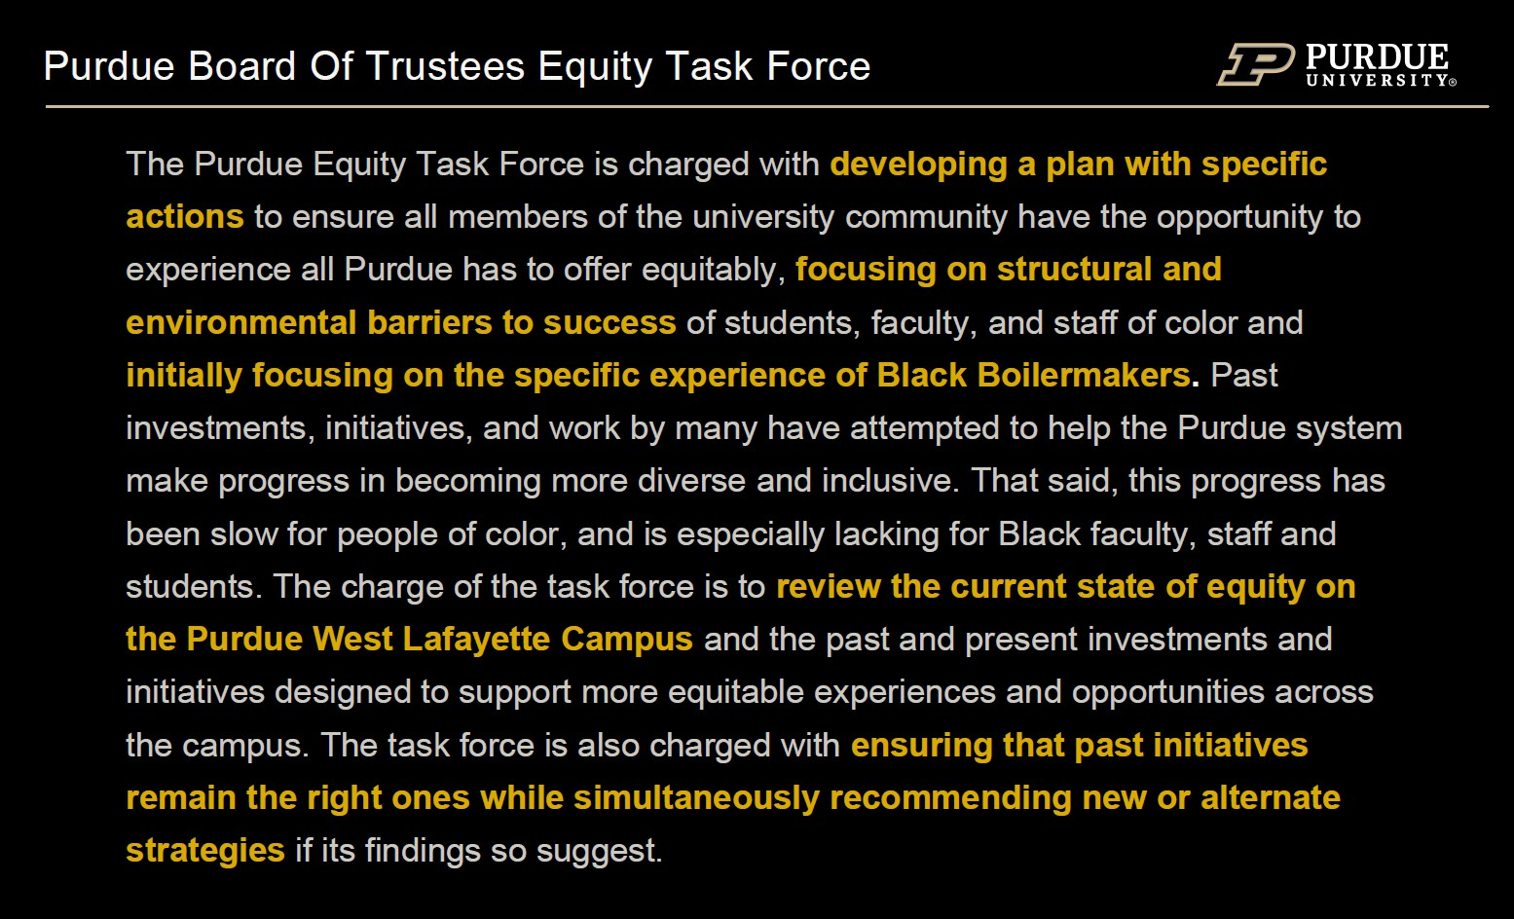
Image Transcript: The Purdue Equity Task Force is charged with developing a plan with specific actions to ensure all members of the university community have the opportunity to experience all Purdue has to offer equitably, focusing on structural and environmental barriers to success of student, faculty, and staff of color and initially focusing on the specific experience of Black Boilermakers. Past investments, initiatives, and work by many have attempted to help the Purdue system make progress in becoming more diverse and inclusive. That said, this progress has been slow for people of color, and is especially lacking for Black faculty, staff and students. The charge of the task force is to review the current state of equity on the Purdue West Lafayette Campus and the past and present investments and initiatives designed to support more equitable experiences and opportunities across the campus. The task force is also charged with ensuring that past initiatives remain the right ones while simultaneously recommending new or alternate strategies if its findings so suggest.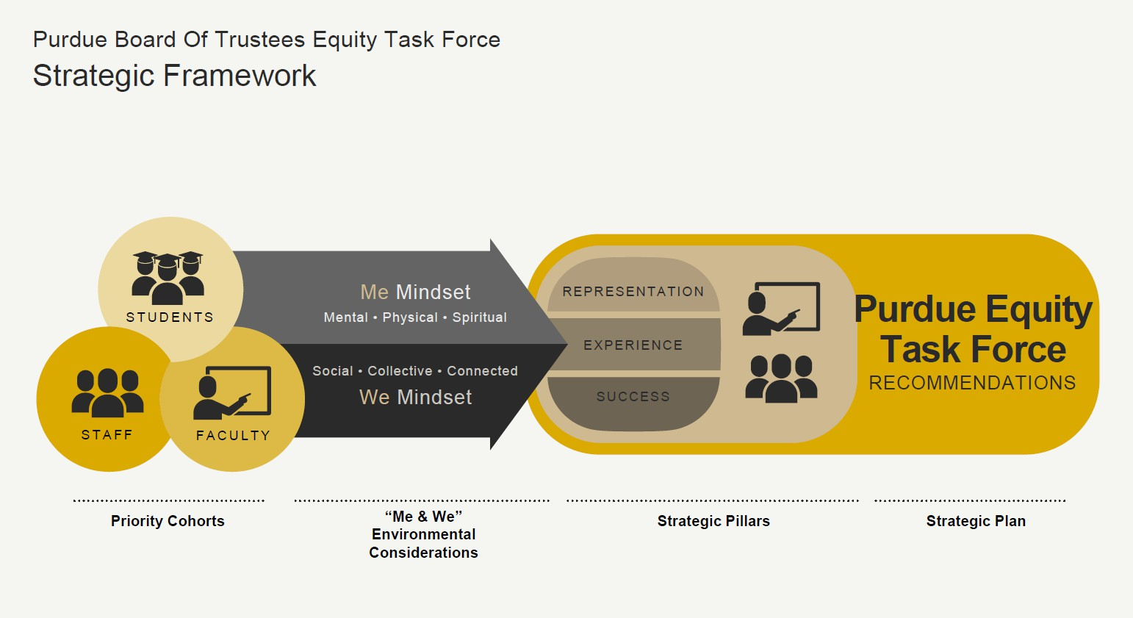
Image Transcript: Purdue Board of Trustees Equity Task Force Strategic Framework. Staff Students and Faculty with the Me Mindset (Mental, Physical, Spiritual) and the We Mindset (Social, Collective, Connected) find Representation, Experience and Success within the Purdue Equity Task Force Recommendations. The Priority Cohorts are the Staff, Students and Faculty which lead into the Me & We Environmental considerations. These areas lead to the Strategic Pillars or Representation, Experience and Success which, in turn, give the Purdue Equity Task Force Recommendations a Strategic Plan.
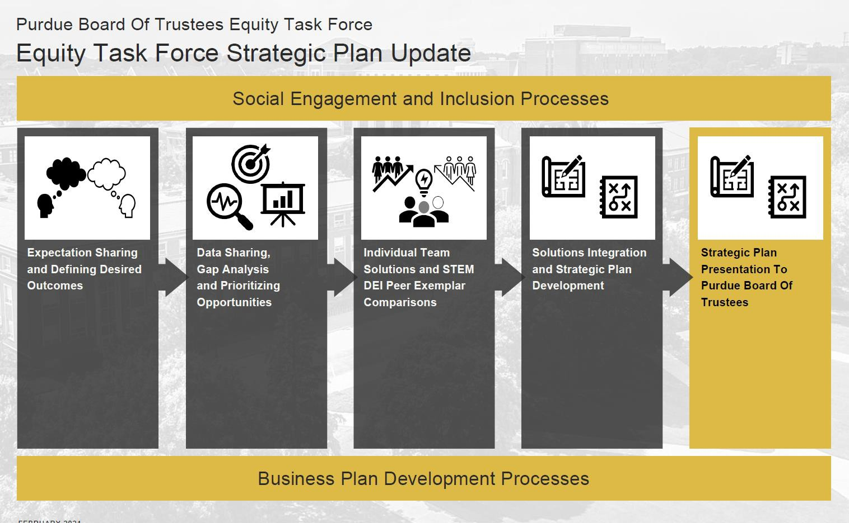
Image Transcript: Purdue Board of Trustees Equity Task Force – Equity Task Force Strategic Plan Update. Social Engagement and Inclusion Processes. Going from: Expectation sharing and defining desired outcomes to Data sharing gap analysis and prioritizing opportunities to individual team solutions and STEM DEI Peer Exemplar comparisons to Solutions Integration and Strategic Plan Development to the final version Strategic plan presentation to Purdue Board of Trustees. These steps are the Business plan development processes.

46 | P a g e

Purdue Board Of Trustees Equity Task Force
How we got here

- August 2020 II
Purdue University Board of Trustees August establishes Diversity Task Force and names Don Thompson Chair; Board provides Task Force to be led by a Steering Committee
Dean's Advisory Group fanned and groups begins to meet
2020 II Steering Committee Membership Announced;
August

  - September 2020 If
Steering Committee meets weekly and establishes 150+ member Working Group to solici1input from a broader Purdue constituency

    - October 2020 ff

    - October - December II
Working Groups meet frequently and craft

recommendations; Integrating Teams created to
synthesize findings led Venetria Patton. Willie
Reed, Patrick Wotf, Barrett Caldwell

•
Mid-December - January II
Recommendations | from Integrating Teams
considered by Steering Committee and
Final Plan drafted/formalized

Three 1-day Data Set Sessions held & Working Group begins their work, led by Venetria Patton with John Gates & Barrett Caldwell
      - February 202111 Presentation of Plan to Board of Trustees for deliberation

August 2020 September 2020 October2020 November 2020 December2020 January 2021 February2021



Purdue Equity Task Force
Strategic Plan Framework
c...:r" UNIVERSITY•
t;""-=->PURDUE
FaR-..au
� REPRESENTATION
� EXPERIENCE
PUPDUEF□RY□U
� SUCCESS
DESTINATION PURDUE
PUPDUEFDRLIF'E
FCRLIFE

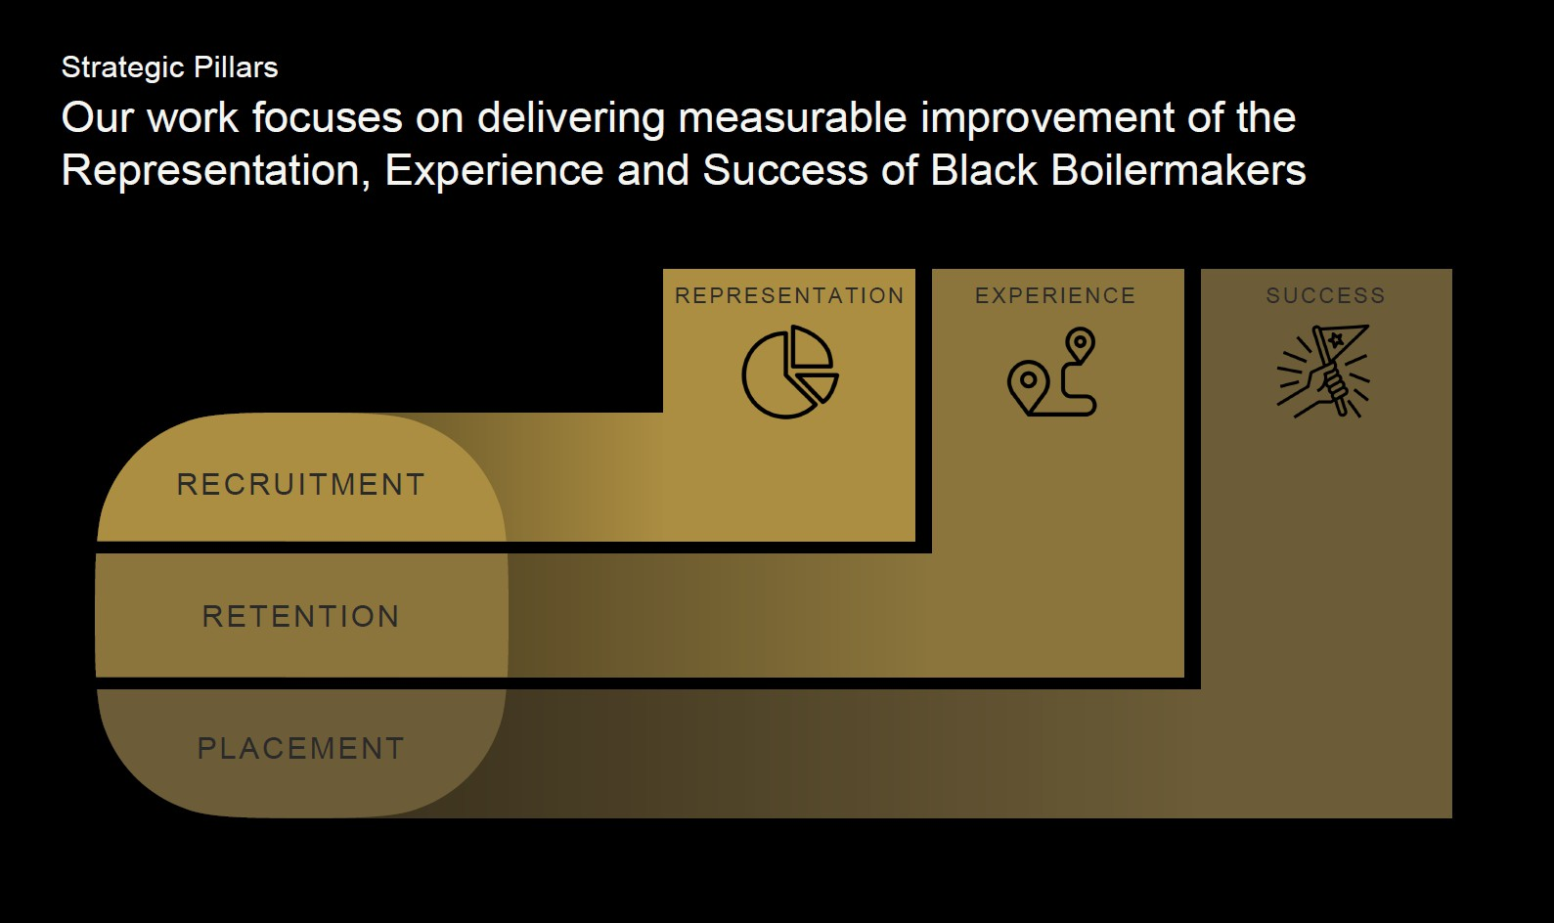
Image Transcript: Strategic Pillars. Our Work focuses on delivering measurable improvement of the Representation, Experience and Success of Black Boilermakers. The graphic shows that Recruitment leads to representation, Retention leads to experience and placement leads to success.
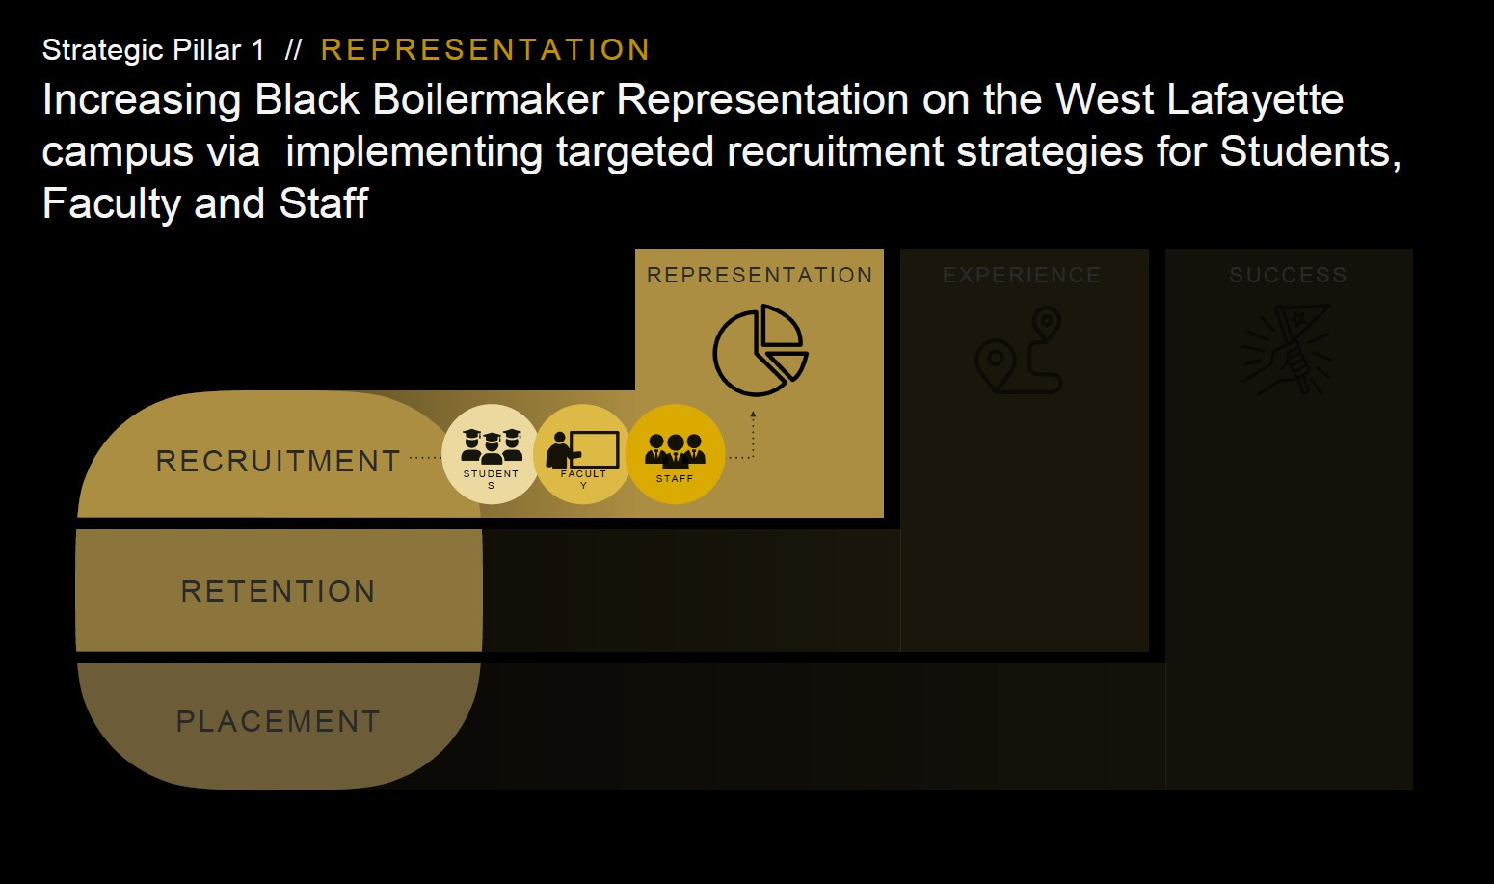
Image Transcript: Strategic Pillar 1 Representation. Increasing Black Boilermaker Representation on the West Lafayette campus via implementing targeted recruitment strategics for Students, Faculty and Staff

48 | P a g e

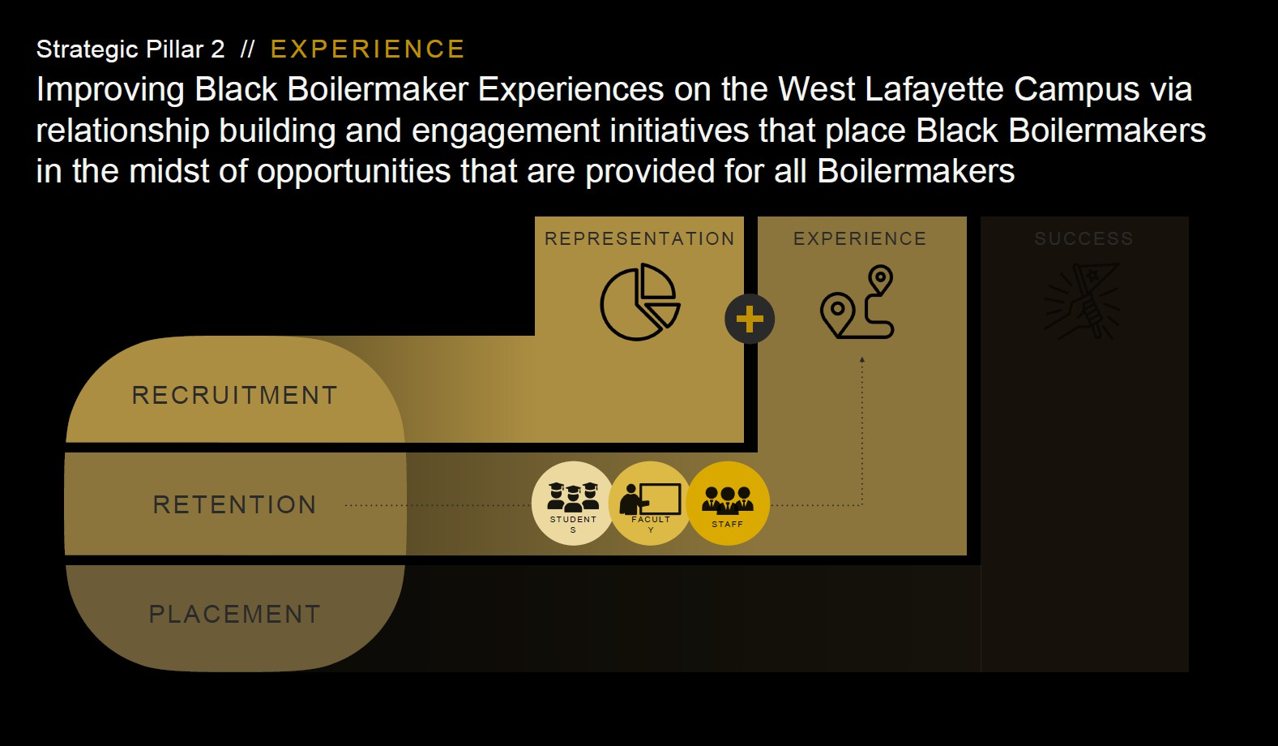

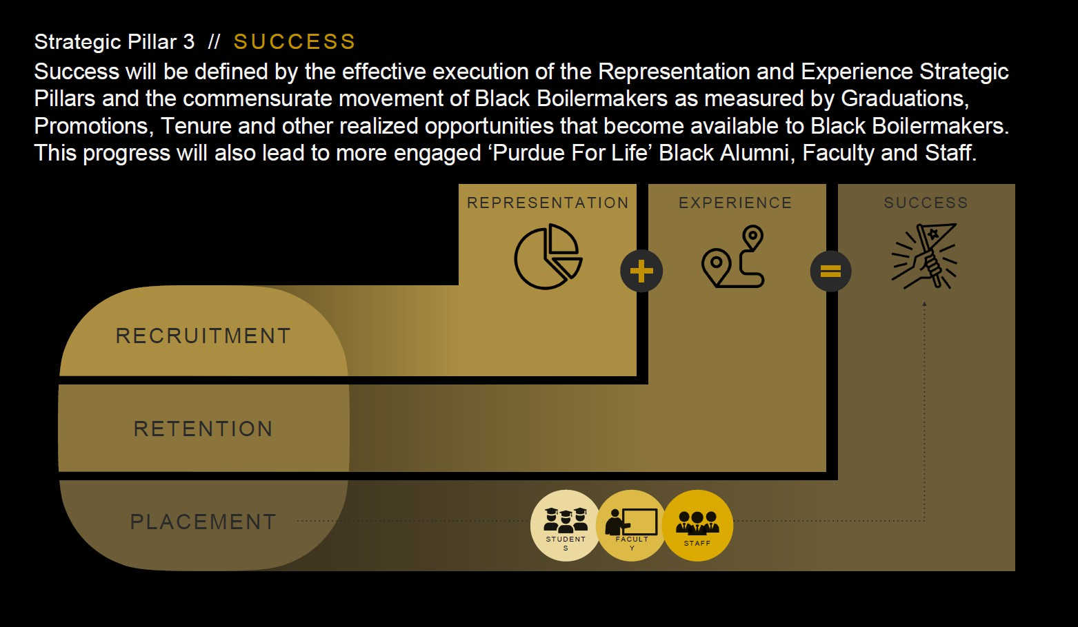

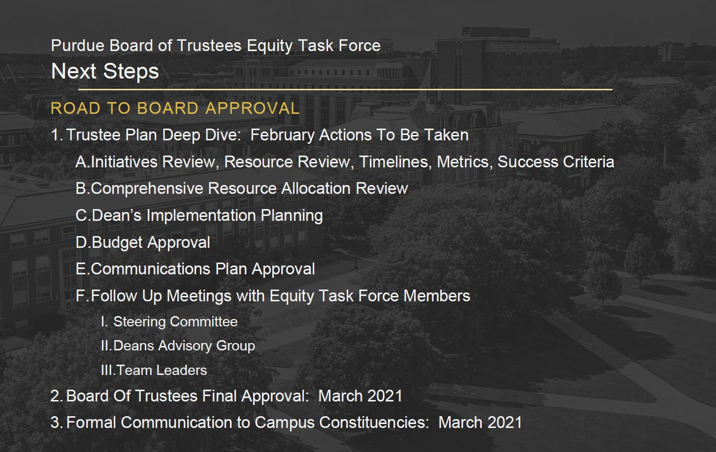

50 | P a g e

